Big Data
What is Big Data?
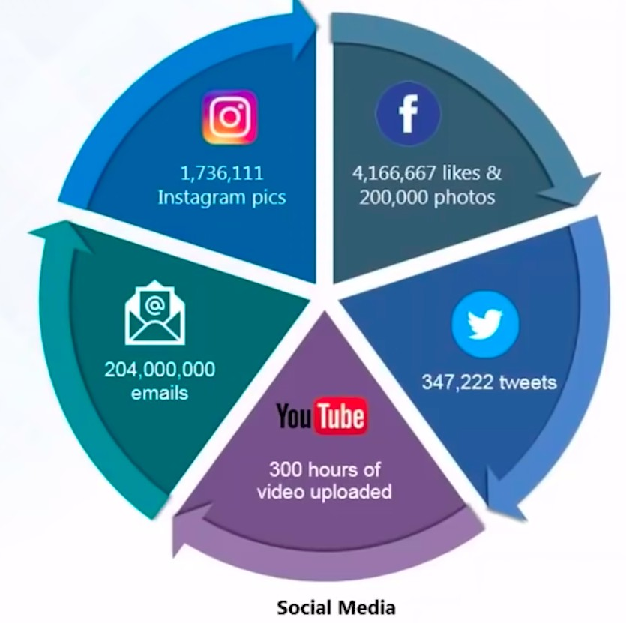

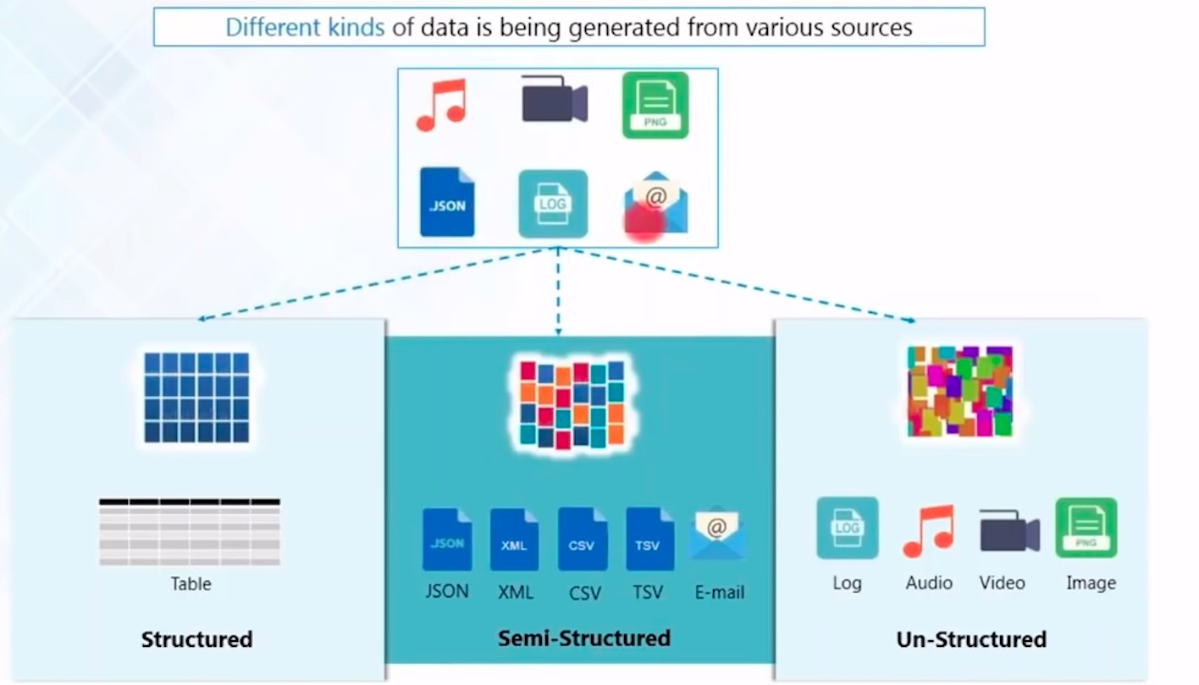
DATA Analytics -

Everyone is creating almost 40 Exabytes data per month

Careers in Big Data -
- Data Analyst
- Data Scientist
- Big Data Architect
- Data Engineer
- Hadoop Admin
- Hadoop Developer
- Spark Developers
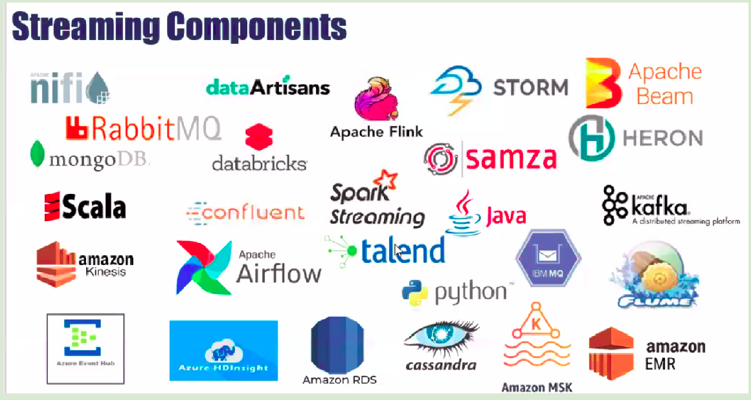

Big data Evaluation -
- 1960 - txt ﬁles
- 1970 - spreadsheets/DBMS
- 1980 - RDBMS but Licenced
- 1990 - Data warehouse (many RDBMS) - Damm costly
- 1995 - DFS found by Doug Cutting but failed due to processing wasn’t good
- 2003 - Google released GFS paper same as DFS == GFS
- 2004 - Google Released Mapreduce paper → Distributed Processing → Doug Cutting read the paper and was Shocked
- 2005 - DFS enhanced and use Mapreduce
- 2006 - DFS + Mapreduce = Hadoop (name on son's elephant Doll) , HDFS and Mapreduce

- 2008 - Emerged a lot -- Problem -- Hey Mapreduce code is damn hard to understand JAVA —> Doug Cutting said --> do not worry I have a solution to simplify MapReduce
—> Learn SQL —> Trigger SQL —> I will ensure my TOOL converts SQL query to Mapreduce JAVA
- I found a tool, it looks like SQL but not --- If you trigger any queries -- it converts into a Mapreduce JAVA
- In 2008 - Hive and Pig came into the market
  - Mark Zuckerberg --- Facebook using --- HIVE
  - Yahoo--using -- PIG (Not Popular)
- 2009 - CLOUDERA - Problem was --for installation and Maintenance -need Laptop
  - Give me Laptop but Installation, maintenance, and Upgrade - are Paid services
- 2011 - Horton Works - Give me laptop and Installation —> Free, Maintenance and Upgrade are Paid
- 2014 - SPARK - Birth of a super Power
  - Superpower, Process data very faster, Free of cost, Will perform SQL, Will support Streaming, Will support Machine learning, can run ON Hadoop
- 2016 - Cloud - I will give u laptops, I will install, upgrade, and Maintenance
  - AWS EMR - Single Click of Button Hadoop Laptops will be ready within 10 Min by AWS
  - Azure HDInsights
  - Google data Proc (Google cloud platform - GCP)
  - Alibaba cloud
- 2017 - Cloudera Bought Horton works
- 2022 -- We live in the Cloud Big Data market = Cloud-based Hadoop Big Data analytics

Cloud Hadoop Spark ===> Crazy Technology today

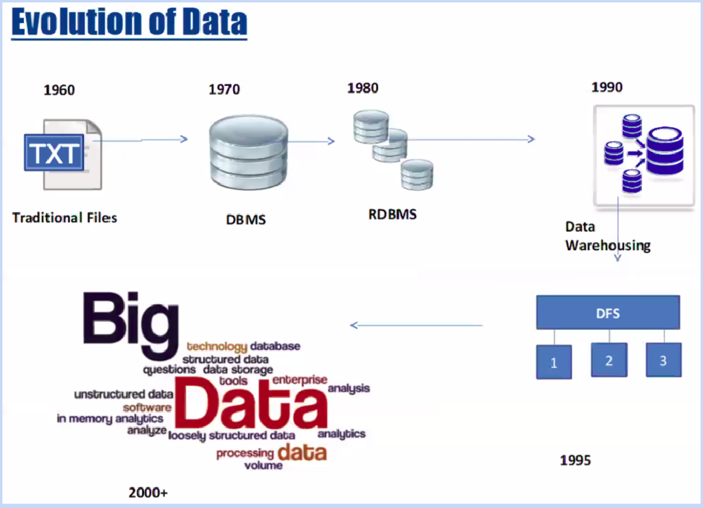

What is DFS -
Introduced by Doug Cutting in 1995.

- License-free
- We don’t need RDBMS servers
- How DFS works - for example there are 4 laptops - 1 is Gateway and other 3 are interconnected to each like below image -
  - Gateway - Once you give data, data gets stored on the Gateway node ﬁrst then after running a few commands it is distributed in other 3 nodes.

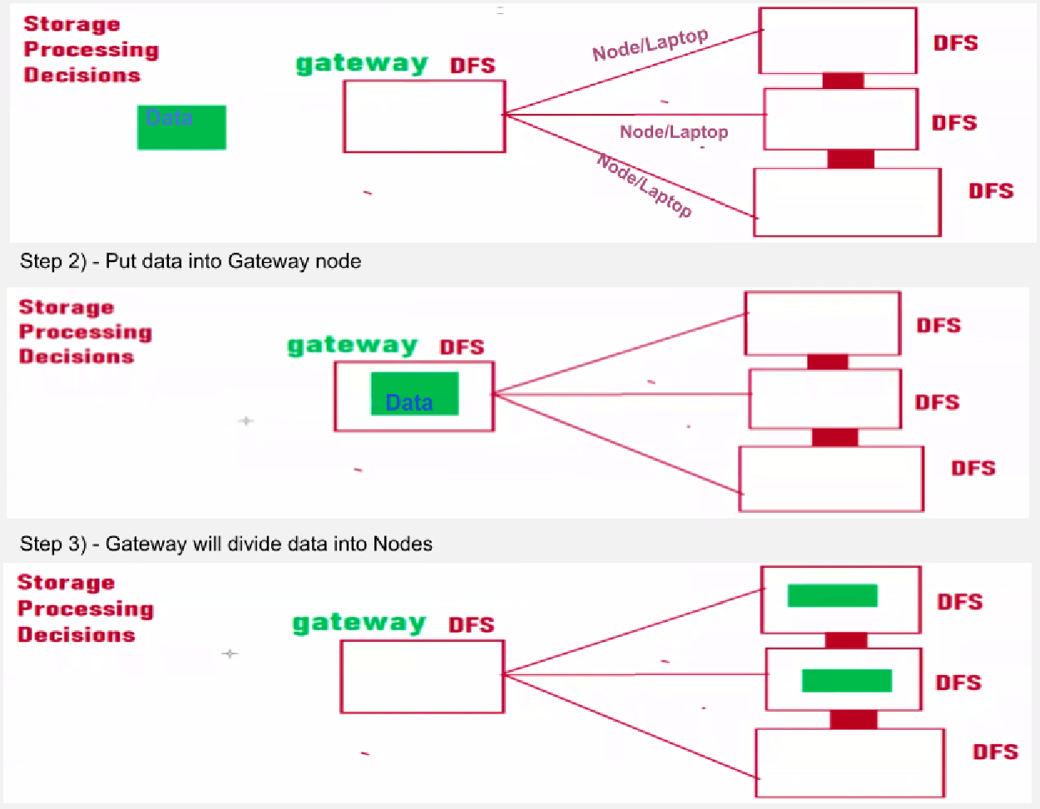

- Why DFS failed - As per Doug cutting if data increases then have to increase Gateway Node size as well to process the data. Which was really an issue, as putting a lot of money for Gateway Node

How is GFS different from DFS -
GFS(Google ﬁle system), they are using the same mechanism to store data as DFS but for processing data GFS uses Map-Reduce. It means data won’t come to process instead process will go to data and Map it after collecting data from all nodes data gets reduced and returned.

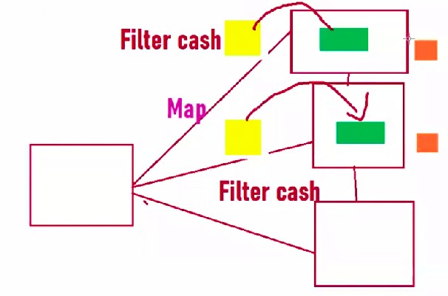

Data is getting reduce -
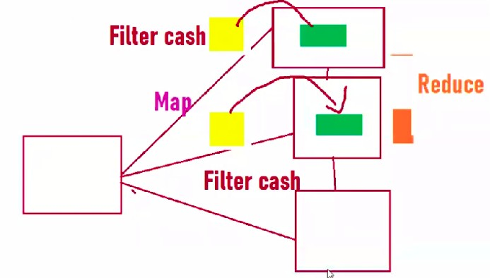

Why Big data?
- 80% of data is unstructured which is challenging to analyze.
- Structured formats limitation in handling large quantities.

5 V’s - (now its 6 V’s)
- Volume
- Variety
- Value
- Velocity
- Veracity - Data can’t be perfect in a realistic environment, it will have inconsistencies, errors, and noise. For instance, collecting data for marketing surveys but there can’t be data from fake accounts.
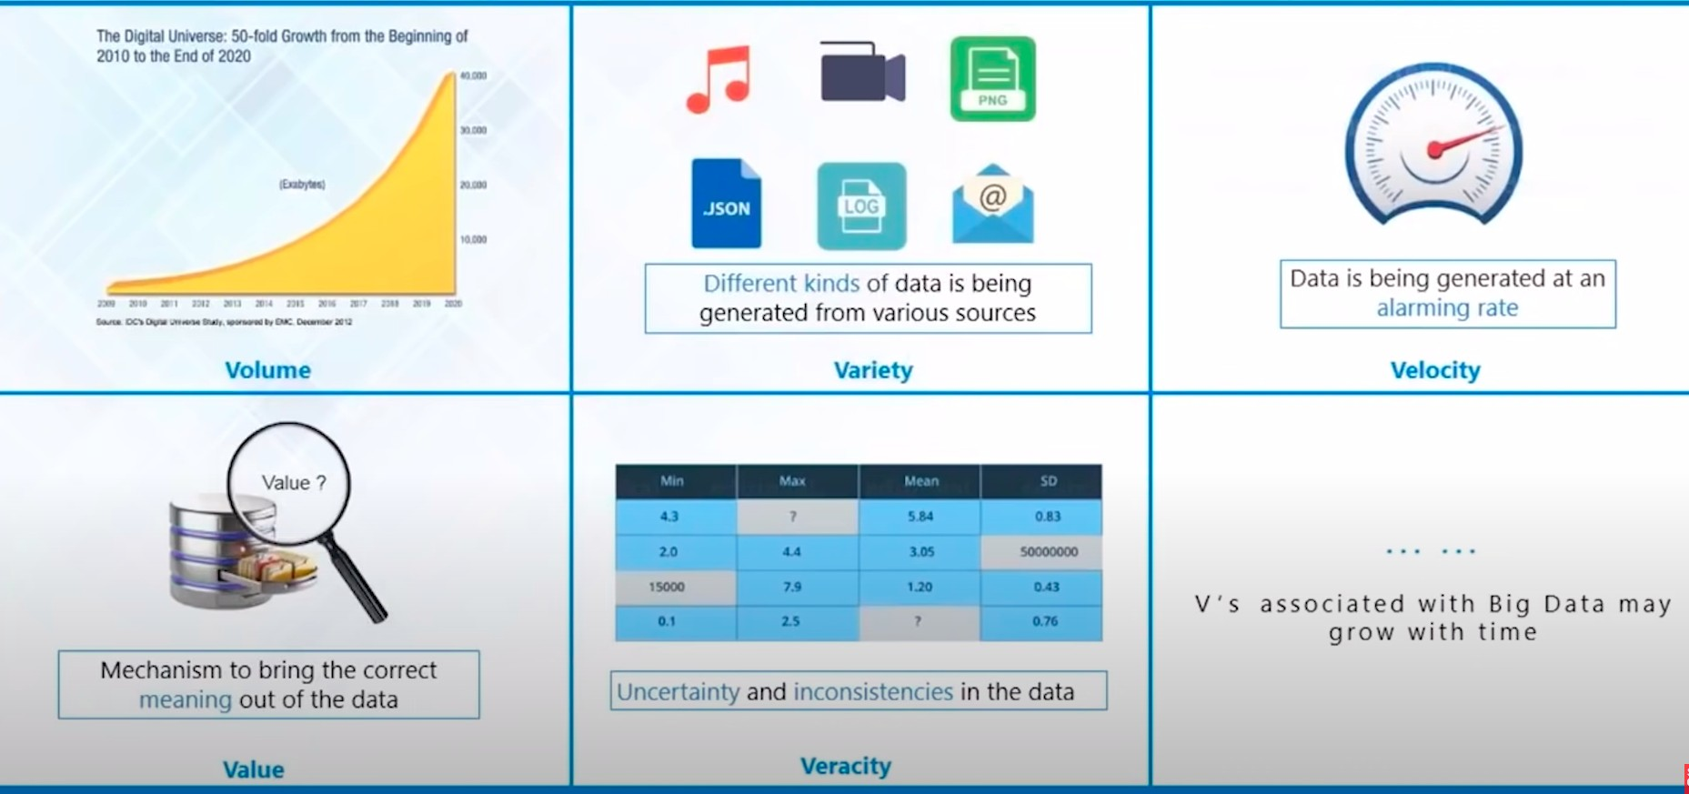
- Variability - Data ﬂow is inconsistent with period peak. The same tweets can have different meanings based on the content.

Challenges of Big data -
- Cost
- Handle a variety of big data - structured and unstructured
- Scalability
- Store the sheer size of data

- Process the huge data - There is no sense in just storing lots of data if we can’t process it.
“That’s when Hadoop came to rescue.”

Characteristics of Big data -
- Hard to store - (Solution) HDFS
- Hard to Process - (Solution) MapReduce, Apache spark

Big Data layers -
- Storage
- Processing/Analysis
- Testing
- Data science/ML/AI
- Automation/Scheduling

Big data Use cases -

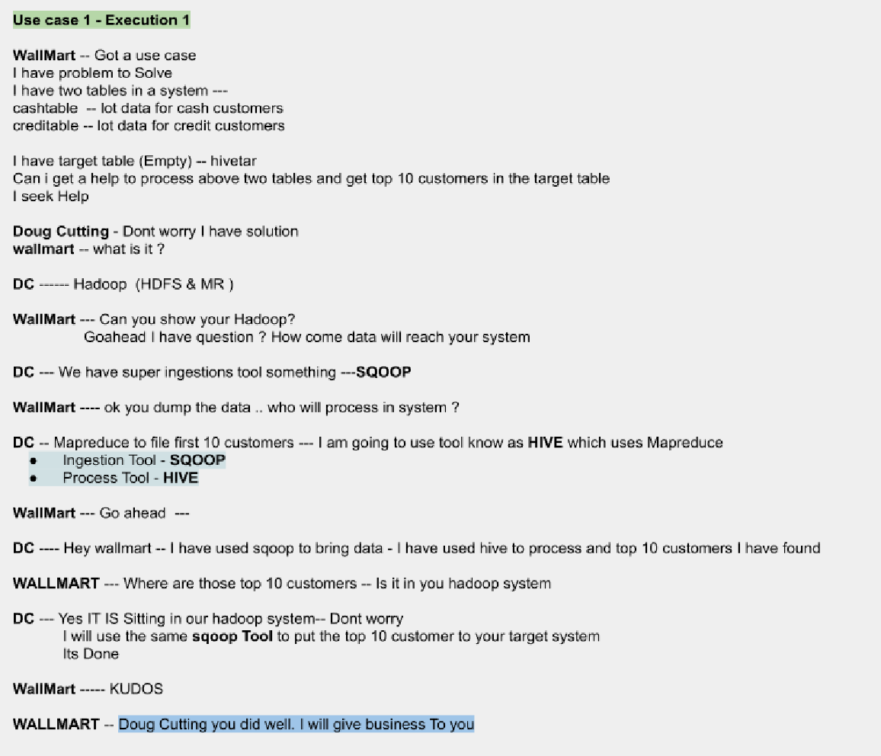

DC used followed below method -
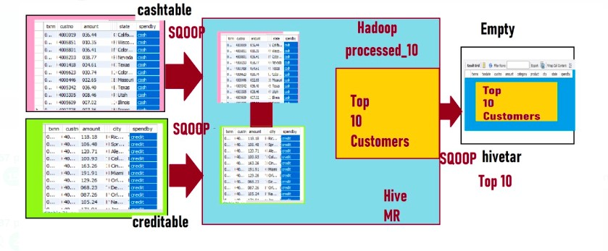

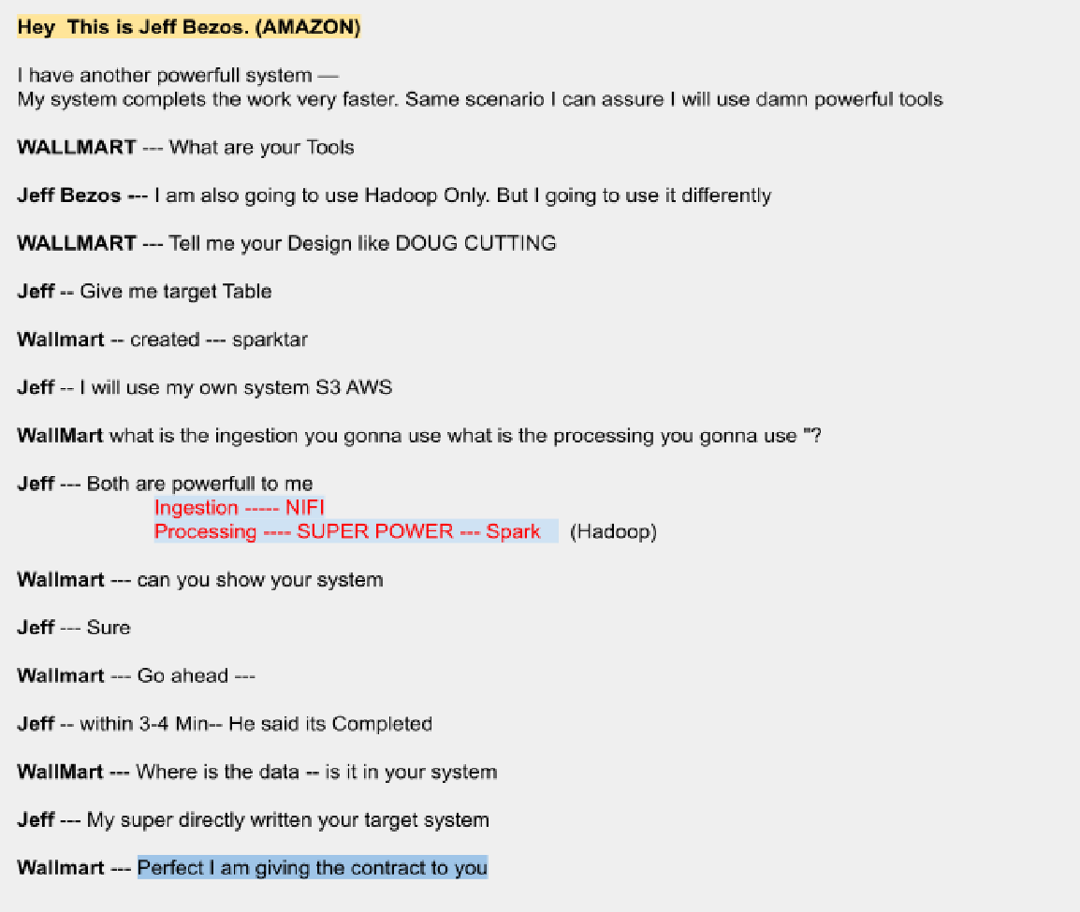
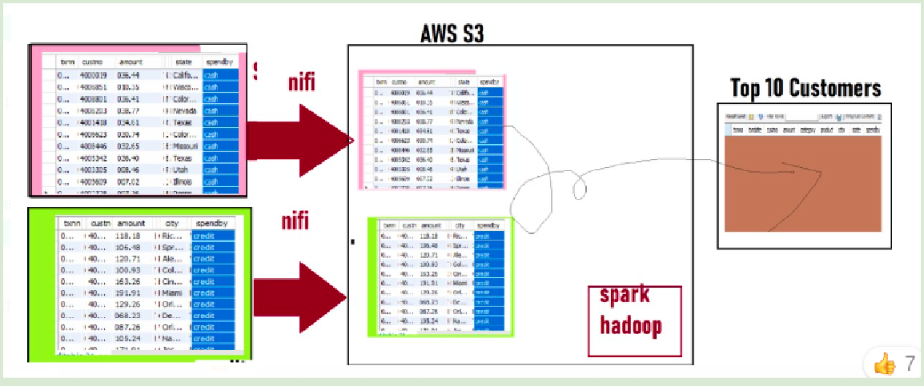

Software needs to install for Big Data learning -
- Windows -

  - Putty/Mobaxterm
  - VirtualBox → install Cloudera inside VirtualBox
  - 7zip
- WIndows/Linux/Mac -
  - VirtualBox -> install Cloudera inside VirtualBox

Programming topics need to learn for Big data -
Architecture Access modiﬁer OOPs
Exceptional Handling String Handling
File Handling Collections
Functional Programming JDBC connectivity

Vim editor (Edit a ﬁle)-
- Vi <ﬁleName>
- Enter ‘i’ to enter in “INSERT” mode
- To exit from the ﬁle press ESC
- then enter “:wq!” to exit from vi editor

Hadoop
Hadoop is a framework that uses distributed storage and parallel processing to store and manage big data. It is the software most used by data analysts to handle big data, and its market size continues to grow. There are three components of Hadoop:

- Hadoop HDFS - Hadoop Distributed File System (HDFS) is the storage unit.
- Hadoop MapReduce - Hadoop MapReduce is the processing unit.
- Hadoop YARN - Yet Another Resource Negotiator (YARN) is a resource management unit.

Cluster - Group of Nodes/laptops (including gateway node)
To login into Gateway -
- Tool to use for login into Gateway - Putty, Mobaxterm (for Linux, Mac uses can also use ssh@hostname in terminal)
- you should have a hostname or IP address and username/password.
- If want to talk to Gateway then use - Linux command
- If want to talk to HDFS/ Hadoop-Nodes then use - Hadoop Language
- For example we have 6 node cluster in these 1 node will be gateway node/Edge node to communicate to the other nodes, like image (1)
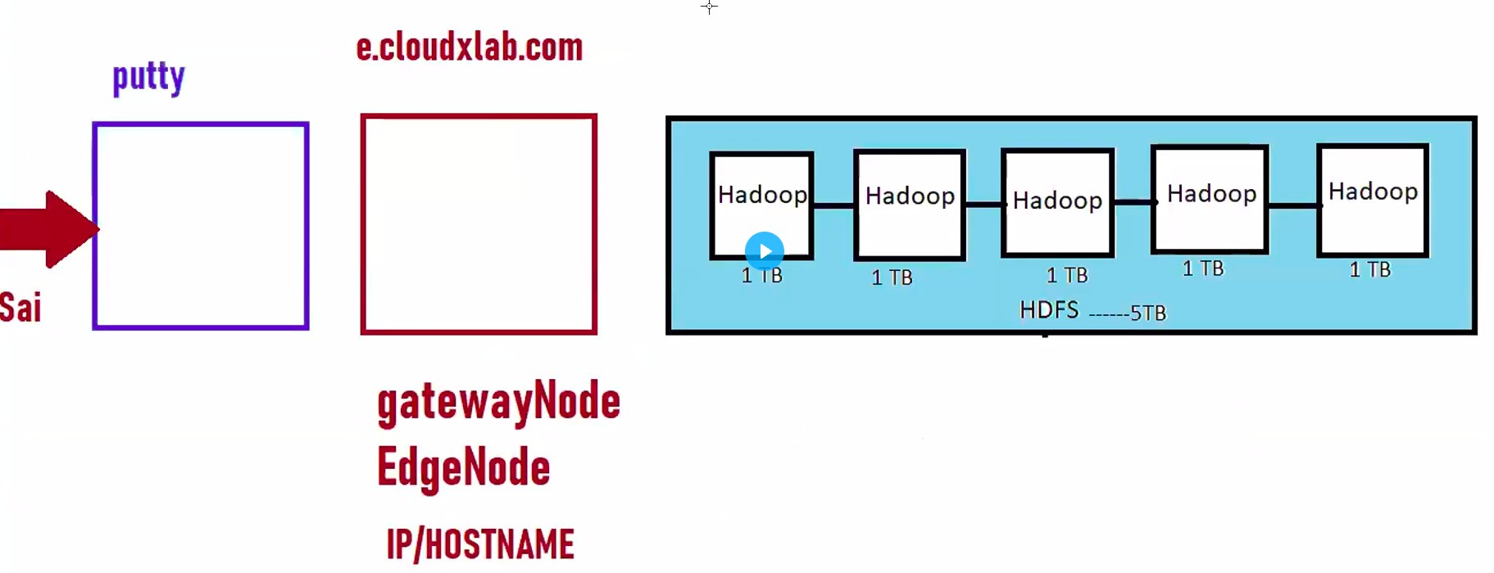

In other 5 nodes, 1 node will be Name node, 1 will be secondary node and remain 3 will be data node, like below image -

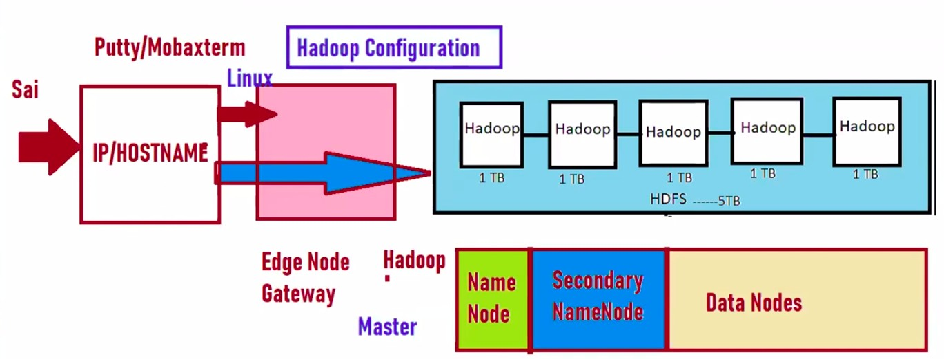
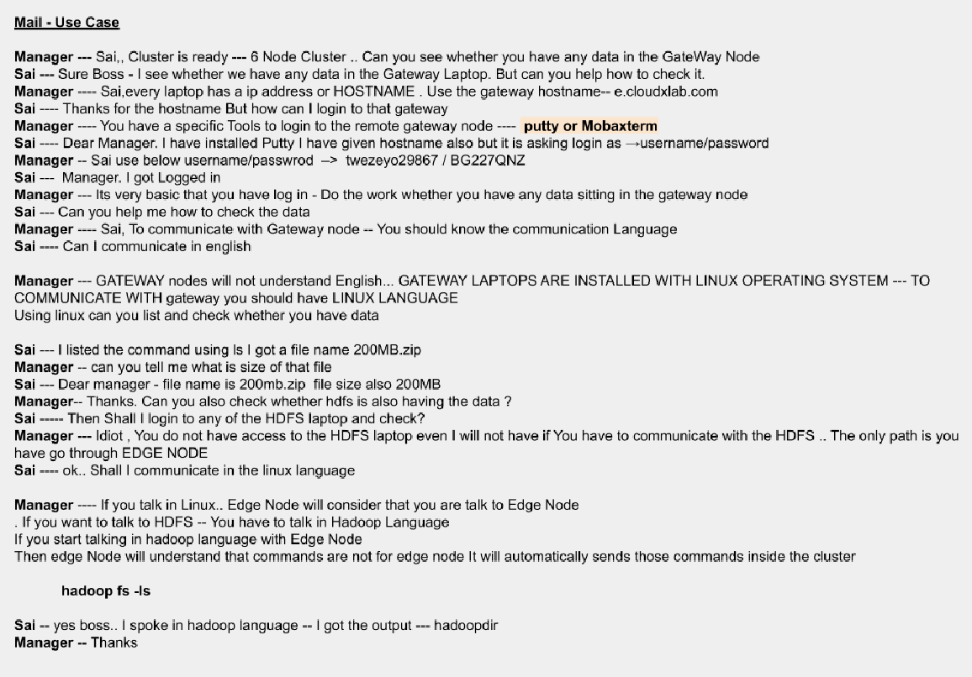

Components of Hadoop
- Name node - Central ﬁle system, contains metadata of Data nodes like(which datanode is alive and which datanode has data, etc.)
Rules of Namenode -

  - Send a heartbeat in every 3 sec to namenode.

  - If you don't send a heartbeat for 10 min I will give grace time and still you still don’t send, I will declare you a dead HDFS node.
  - If you have any work send a copy of the work to 2 other nodes. (There will be 3 copies of Each data)
- Secondary Name node - Data backup of Name Node
- Job Tracker - Centralized job scheduler
- Data Nodes - cluster/machine where data get stored and processed, it is also called slave nodes. Every slave node keeps sending a heartbeat signal to the Name node every 3 seconds to state that it's alive.
- Task Trackers - a software service that monitors the state of the job tracker

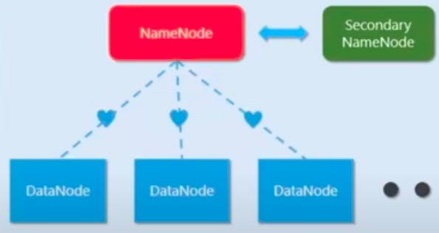

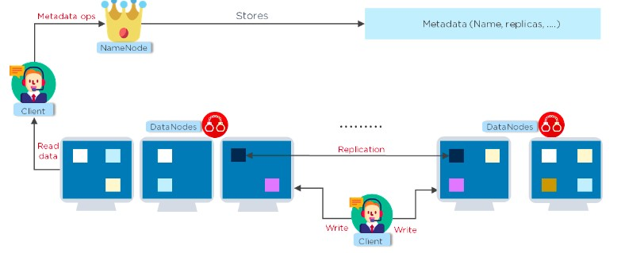

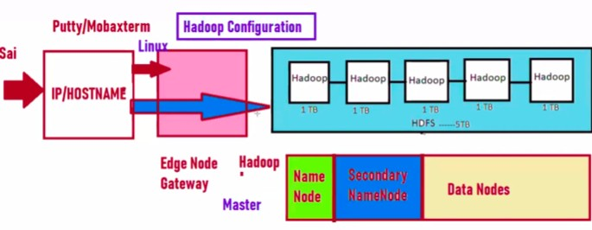

Hadoop 1.0 Architecture -

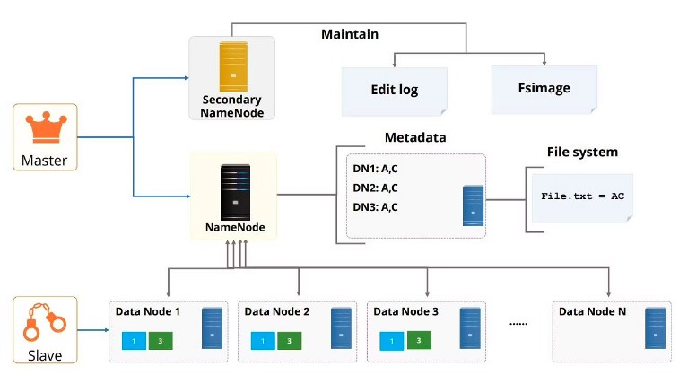

- Once data translation happens, Save metadata in three places of Namenode -
  - FS image - RAM
  - Edit Logs(EL) - RAM
  - FL - HDD (hard disk)
- Then After 1 hour,
  - if this is ﬁrst transaction then Namenode sends the FS Image-HDD –>
SNN(secondary Name node)-FS image
  - Latest EL (RAM) —> SNN-EL
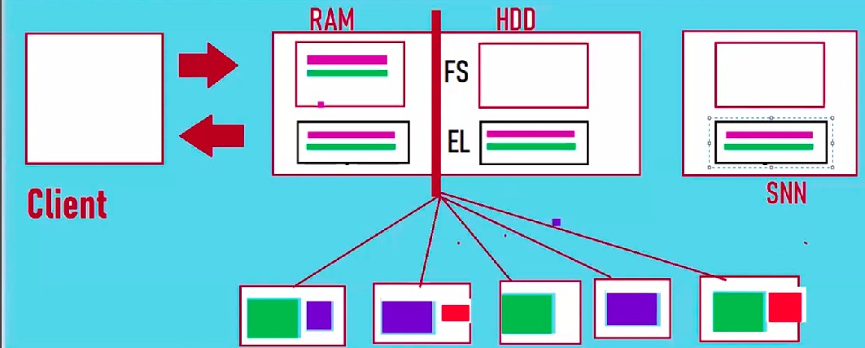

- And Clear EL - RAM and EL- HDD of Namenode

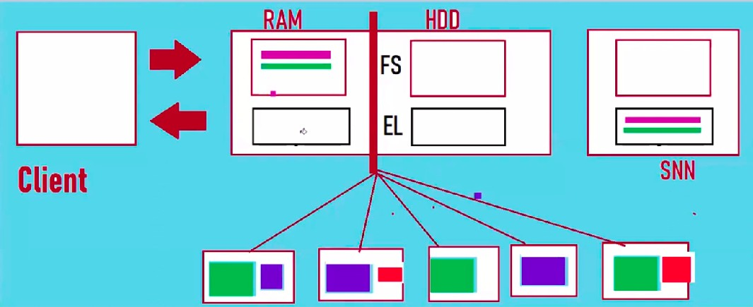

- Then Checkpointing(Merge) SNN- EL data to SNN-FS image and then send SNN-FS image to HDD-FS image.
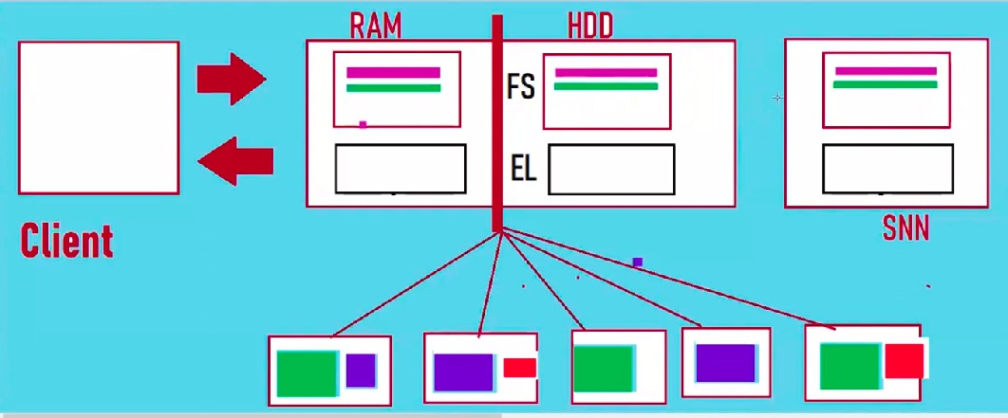

- What if Namenode- RAM crash, then Namenode immediately goes to SAFE MODE,

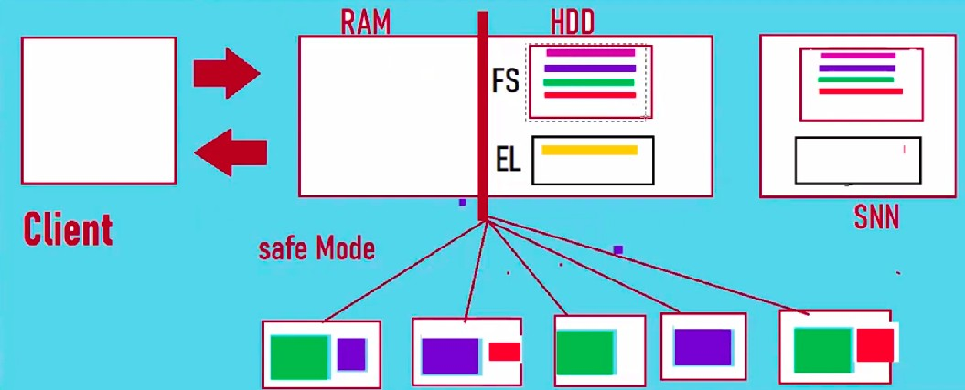

- Then Namenode will take FS images and EL from HDD(Namenode).
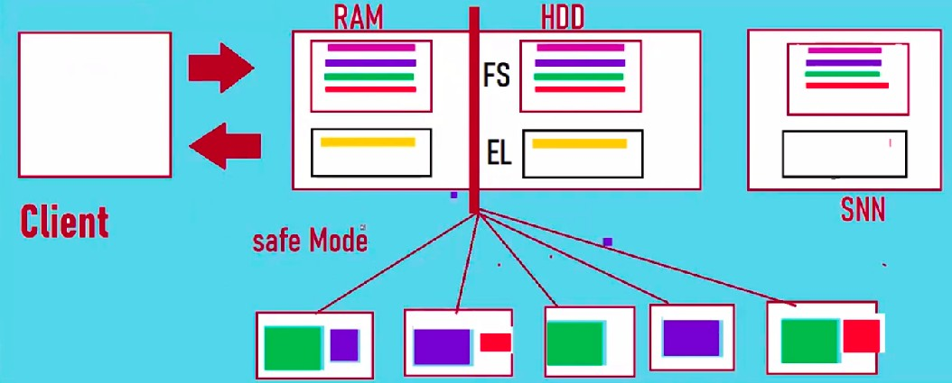

- And will Checkpointing(Merge) Data of EL- RAM (namenode) to FS image- RAM(namenode)
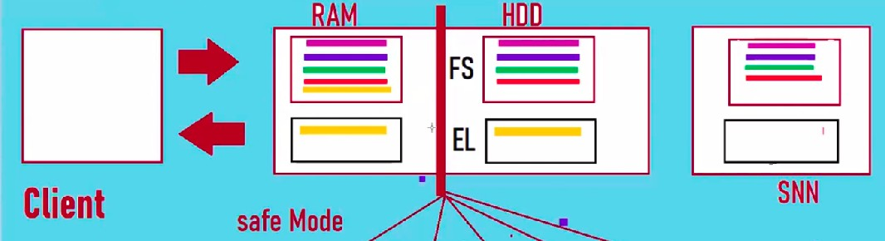

FS image -
- Why FS image can’t be committed to the hard disk every time there is new data - because FS image is huge in size and it will slow down the system, also if that time Client asks for metadata from Name node it will not respond properly.
- FS image in Hard Disk should be copied during restart time.

Important Notes for Hadoop 1.0 -
- Each transaction will be divided into Blocks, and its size is 128 MB(in Hadoop 1.0 Block size - is 64 MB). Suppose the transaction is 200 MB then it will divide into 2 blocks → 128 MB and 72 MB
- These conﬁgurations can be edited and set as per requirement for Edge Node -
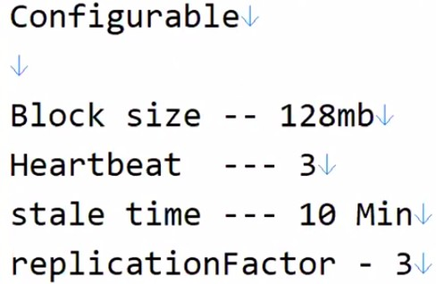

- If the transaction is not replicating data to other data nodes then the name node will throw notiﬁcation failure.

Defects of Hadoop 1.0
- Data Loss - Namenode failure was a threat. Suppose after the New data transaction namenode completely fails, then there is no data recovery in that case as we can’t depend on SNN because it doesn’t have the latest FS image.

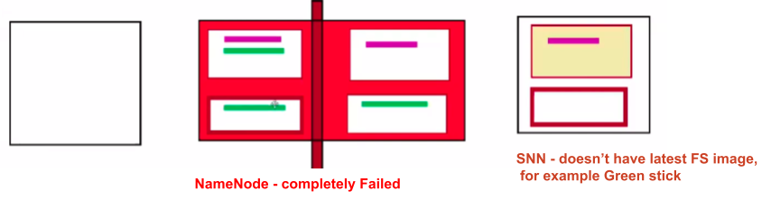

Hadoop 2.0 Architecture
2 New nodes were added -

- Journal Node
- Zookeeper

Rules of Zookeeper-
- Secondary namenode renamed as Standby node.
- Name node(Active name ode) will write Edit logs to Journal Node.
- Standby name node, During checkpoint have to read form Journal node.
- If required(in case of name node failure), the Standby namenode has to become Active name node.
- Datanodes have to send a heartbeat to both Namenode and Standby Namenode. But metadata will only be sent to Namenode.
- Whichever is the Active node - it will have ﬁle - in_use.lock as a representation that this is the current Active name Node.
- ANN and Standby nodes are interconnected.
- After 1 hour -
  - Read EL - Journal node and write in EL-Standby.
  - If it is the ﬁrst transaction then copy the FS-image of HDD-ANN and save it in the Standby node.
  - And also clear EL-Journal node
  - checkpoint EL-Standby node –> HDD-ANN(active node).

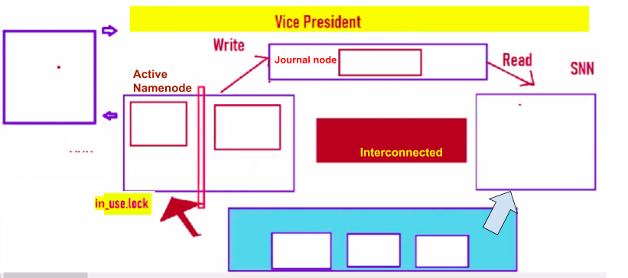

Flow -
- First Transaction - Write FS image in ANN( RAM )and EL in journal node and after 1 hour SNN will read EL from journal node and copy old HDD form ANN(if this is ﬁrst transaction).
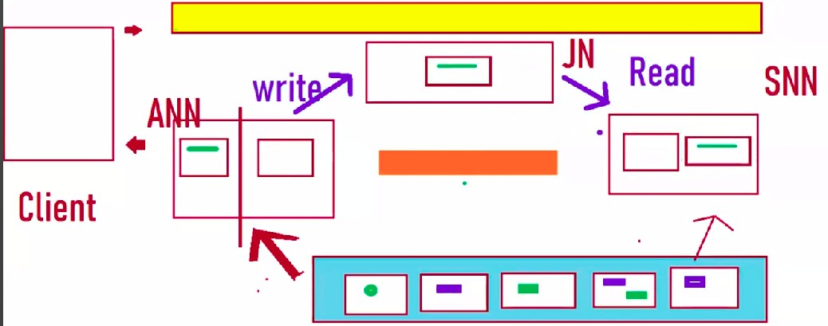

- After one hour there will be checkpointing where SNN merge EL to FS-SNN and copy
FS-SNN to FS-ANN(RAM)

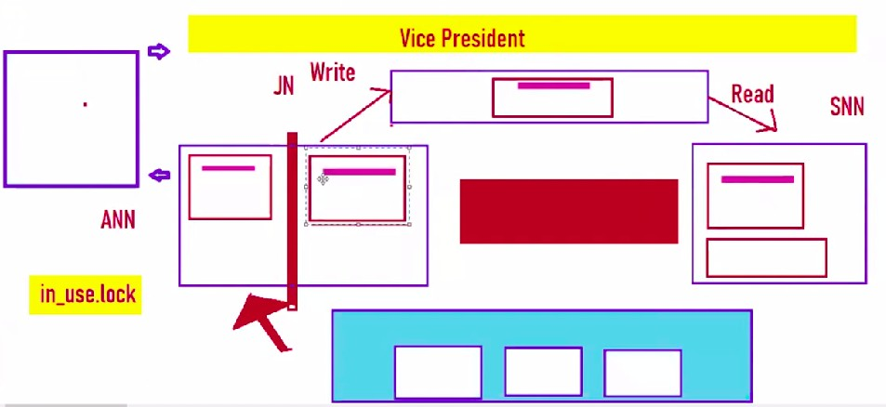

- If ANN goes to complete failure - Then the Standby node will go to SAFE MODE and a new ﬁle wil be created for Standby node - in_use.lock (representing this is the current active node).
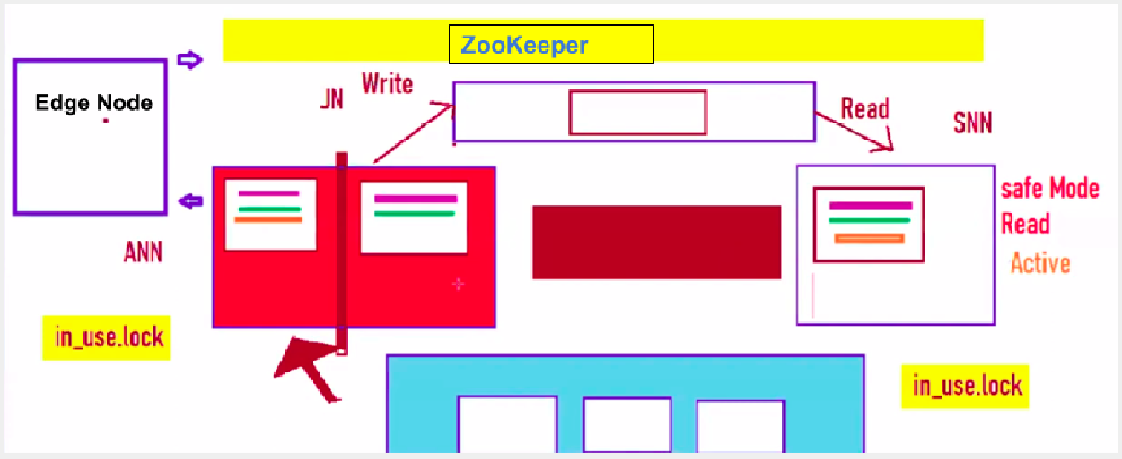

- What if after some time or hours Dead Node(Name node) becomes active - In that case, Both the Dead(name node) and current Active node(standby) will start to write to the Journal node, which means now there will be 2 times EL in journal node, which is an issue. This scenario is called Split Brain Scenario.

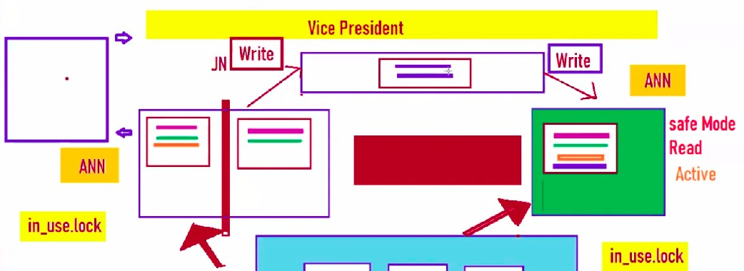

Solution - Doug cutting created a Program Fencing Java Program where Zookeeper sends messages to Dead node, where dead mode will stop writing to other nodes. And Dead node is now Standby node.

Hadoop Commands (just like Linux)-
To talk to Hadoop →preﬁx Linux command with ‘hadoop fs -’
- hadoop fs -ls
- hadoop fs -touchz <ﬁleName> // create a new empty ﬁle
- hadoop fs -cat <ﬁleName> //print ﬁle content on console
- hadoop fs -put <edgeNodePath> <HDFSPath> // copy ﬁle from edge to HDFS
- hadoop fs -get <HDFSPath> <edgeNodePath> // copy ﬁle from HDFS to Edge
- hadoop fs -moveFromLocal <edgeNodePath> <HDFSPath>
- hadoop fs -moveToLocal <HDFSPath> <edgeNodePath>
- hadoop fs -appendToFile <sourceFilePath> <targetHDFSPath>
- hadoop fs -rmdir <path> //delete folder
- hadoop fs -rm -r <path> //delete folder and ﬁle inside it
- hadoop fs -rm <path> // delete ﬁle
- hdfs dfsadmin -safemode get //→ﬁnd out if you're in safe mode
- hadoop dfsadmin -safemode leave //→turn off safe mode
- hdfs dfsadmin -report //→ﬁnd out how much disk space is used, free, under--replicated, etc.
●

Hadoop Ecosystem

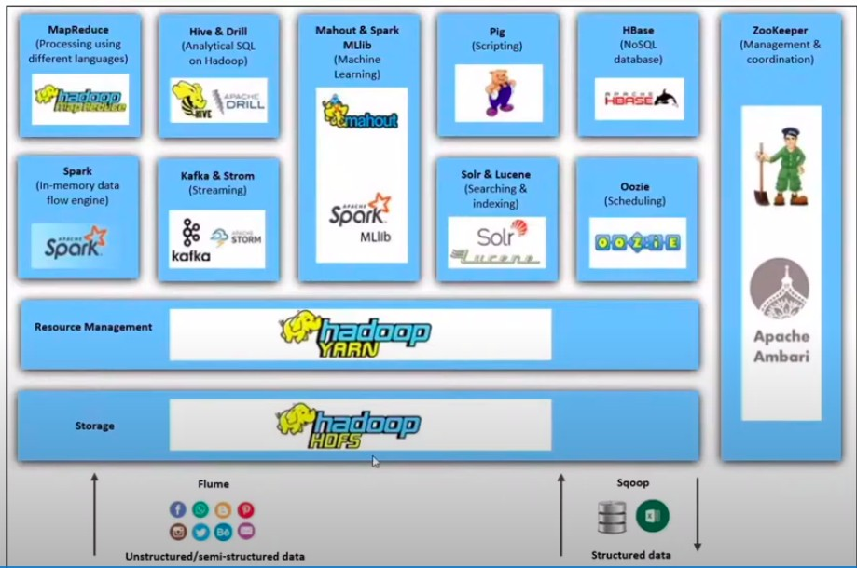
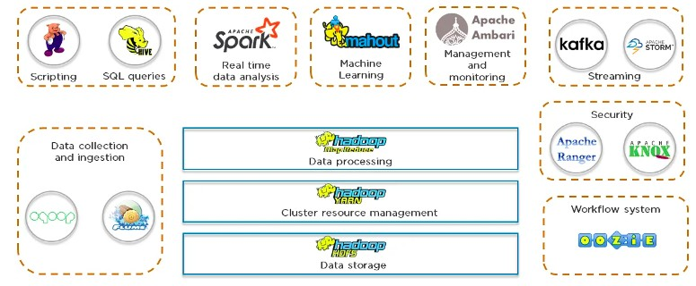

Cloudera

Installation →
- Prerequisites - Install virtual box [sudo apt install virtualbox]
- Article -
https://www.simplilearn.com/tutorials/big-data-tutorial/cloudera-quickstart-vm

How to Login into Edge node/Gateway node
  - Login direct into Cloudera by opening VirtualBox with Cloudera installation
  - By putty, mobaxterm, or ssh as per OS -
    - Windows - Open putty and provide host IP and connect
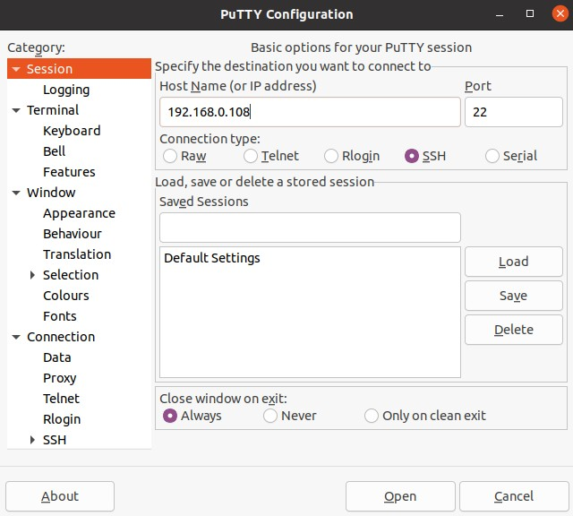
    - Linux/Mac -
      - Either install putty and connect OR run below command
      - Go to Terminal → ssh <user_name>@<remote_host>
        - For example - ssh cloudera@hostIdAddress

  - Run Command to leave safe mode - hadoop dfsadmin --safemode leave

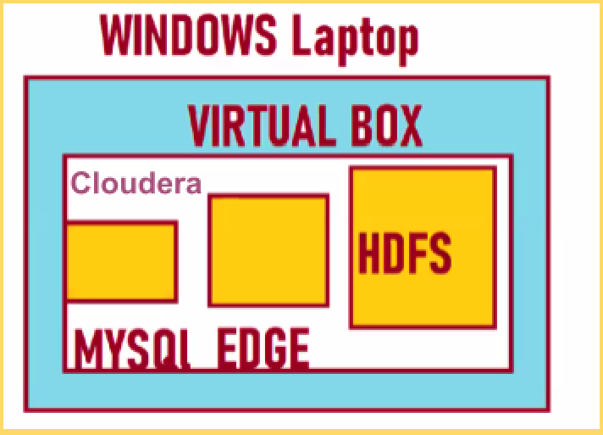

SQOOP -
2009 cloud support - Kathleen Ting
Tool used to transfer bulk data between HDFS and RDBMS
Sqoop word came from SQL+HADOOP=SQOOP
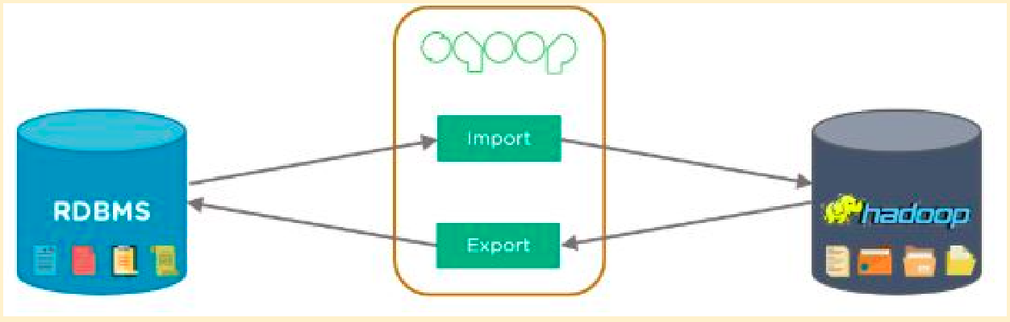

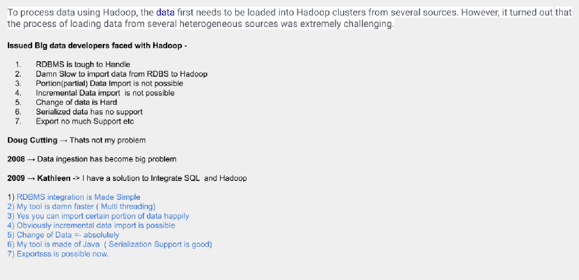

SQOOP Architecture -
Sqoop fetches data from different databases. Here, we have an enterprise data warehouse, document-based systems, and a relational database. We have a connector for each of these; connectors help to work with a range of accessible databases.
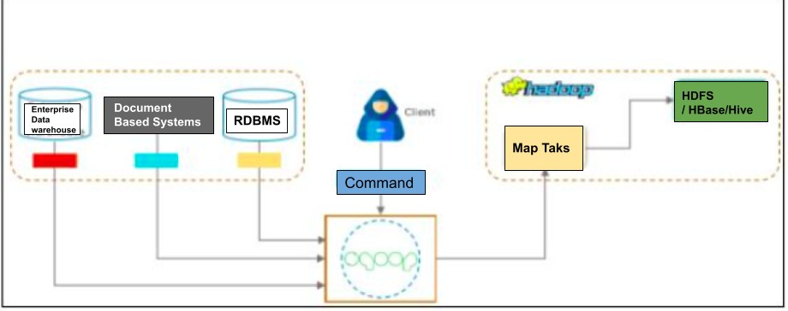

SQOOP Command -
- sqoop import
--connect jdbc:mysql://<hostname>:<portName>/<DBname>
--username <userName>
--password <password>

--table <sourceTableName>
--m 1
--target-dir <targetDirectoryPath>
- sqoop job --create // Create Sqoop job
- sqoop job --list // To check all job list
- sqoop job --exec <jobName> // To run speciﬁc job
- sqoop job --show <jobName> // To check saved job details
- sqoop job --delete <jabName> // To delete job

Prerequisites -
Login into remote Gateway either from SSH or virtualBox cloudera How to Login into Edge node/Gateway node
For big data classes -

- hostname → localhost
- portnumber → 3306
- database → zeyodb
- username → root
- password --> Aditya908
- table → ztab
- targetlocation → /user/cloudera/dimport

For Big data practice class - how to run SQOOP

- We are going to use cloudera in VirtualBox - Open Cloudera and login into MySQL to check if SQL is working
mysql --uroot --pcloudera and now run the below command in SQL
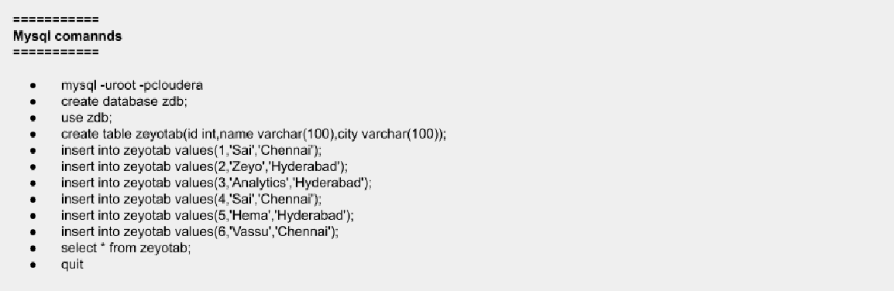
- Open another Tab and Then run below command -

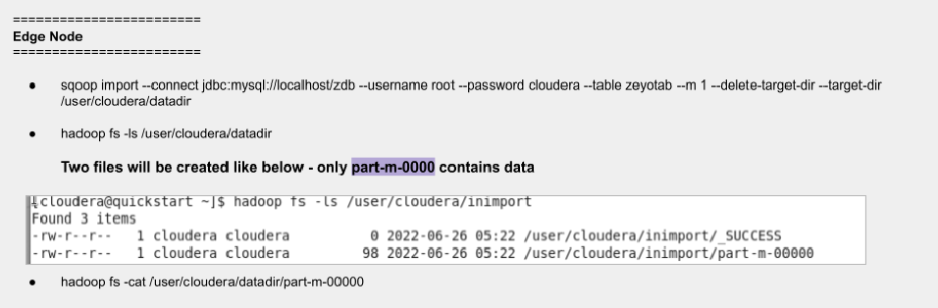

sqoop import --connect jdbc:mysql://localhost:3306/zeyodb --username root --password Aditya908 --table ztab --m 1
--target-dir /user/cloudera/dimport

Partial import data - We have do 2 way

- --where <condition>
sqoop import --connect jdbc:mysql://localhost/zdb --username root --password cloudera
--table zeyotab --where "city='chennai' and id>1"
--m 1 --delete-target-dir --target-dir /user/cloudera/datadir
- --query - for example let join two tables.
  - Important thing for command - this is where \$CONDITIONS compulsory to put wherever using --query command
sqoop import --connect jdbc:mysql://localhost/zdb1 --username root --password cloudera
--query "select a. ,b.product from zeyotab a join zeyoprod b on a.id=b.id where \$CONDITIONS"
--m 1 --delete-target-dir --target-dir /user/cloudera/joindata

  - even if there is any other condition like id>3, put is as -
where id>3 and \$CONDITIONS

Increatmental import data -
sqoop import --connect jdbc:mysql://localhost/zdb2 --username root --password cloudera
--table zeyotab --m 1 --target-dir /user/cloudera/inimport
--incremental append --check-column id --last-value 6

Argument | Description
--check-column (colName) | Speciﬁes the column to be examined when determining which rows to import.
--incremental (mode) | Speciﬁes how Sqoop determines which rows are new. Legal values for mode include append and lastmodiﬁed.
--last-value (value) | Speciﬁes the maximum value of the check column from the previous import.

★ Rules
  - Pick a column that should have only integer-like - numbers, dateTime
  - That column shouldn’t have duplicates otherwise increment process won’t work for duplicates
  - A new part ﬁle will be created for every increment data, Process -
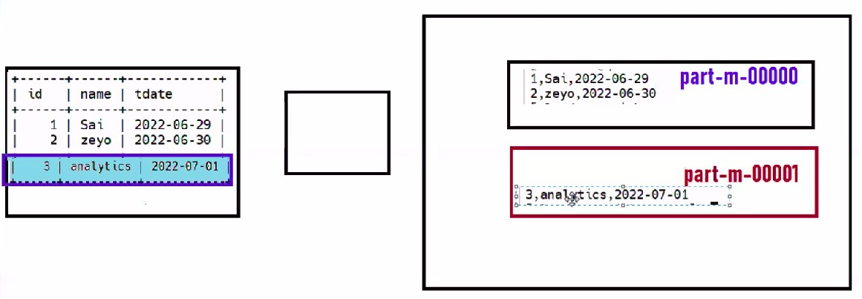

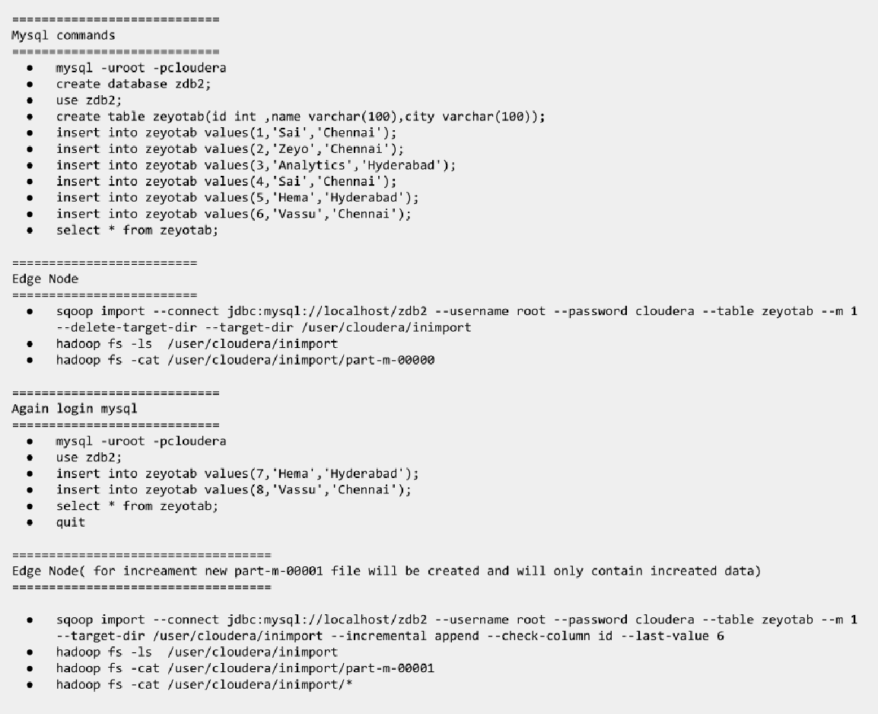

Updated/Modiﬁed import data
Sai Video - https://youtu.be/CGiJf7tAyIk
sqoop import --connect jdbc:mysql://localhost/zdb2 --username root
--password cloudera --table zeyotab --m 1 --target-dir /user/cloudera/inimport
--incremental lastmodiﬁed --check-column dataTime --last-value 6 --merge-key id

Argument | Description
--check-column (colName) | Speciﬁes the column to be examined when determining which rows to import.

--incremental (mode) | Speciﬁes how Sqoop determines which rows are new. Legal values for mode include append and lastmodiﬁed.
--last-value (value) | Speciﬁes the maximum value of the check column from the previous import.
--merge-key (colName) | This column shouldn’t have duplicates

If providing these above 4 details, there will run 2 Map-reduce jobs -
- To bring Data from RDBMS
- To override the data to HDFS

One Case - For example, there are multiple part-m-0000 ﬁles in target dir, and then running the update/modiﬁed command, there will be only 1 part-m-00000 ﬁle and it will have all the data

Using the options ﬁle to Pass Arguments

For example, the following Sqoop invocation for import can be speciﬁed alternatively as shown below:

sqoop import --connect jdbc:mysql://localhost/dbName --username foo –password cloudera --table TEST

TO
sqoop --options-file /users/homer/work/import.txt --table TEST --target-dir /user/cloudera/dataArgFile

★ where the options ﬁle /users/cloudera/work/import.txt contains the following: Make sure to provide a new line for every argument and value like below, also we can add more arguments in the ﬁle if want -
import
--connect jdbc:mysql://localhost/db
--username root
--password cloudera

SQOOP-All-Tables-Import-
sqoop import-all-tables (generic-args) (import-args)

SQOOP Job -
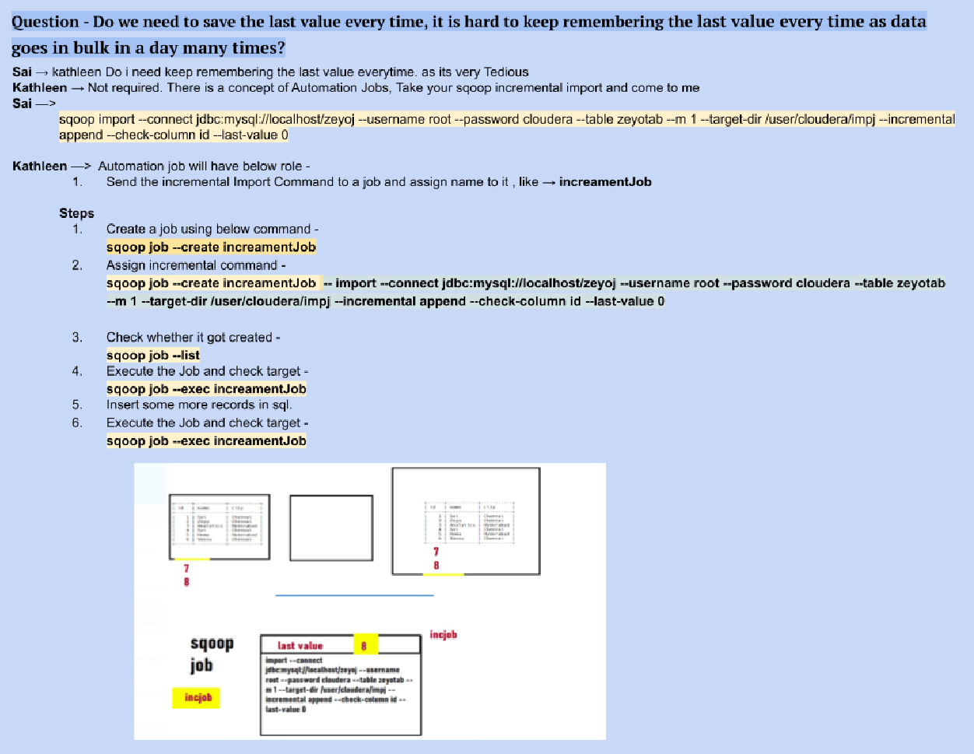

Serialization File Types

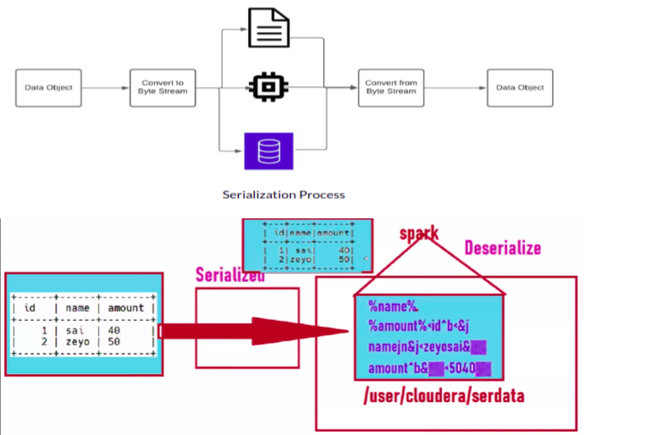
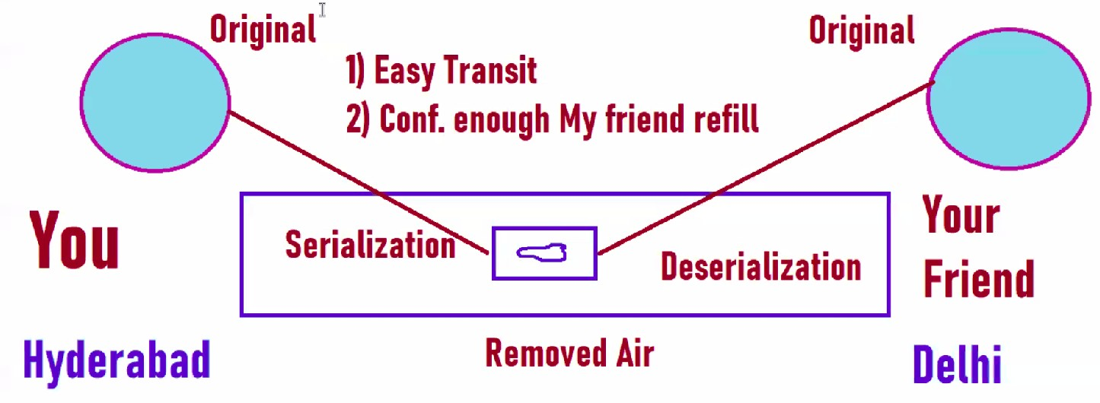

Below are serialization ﬁle formats.

- Text ﬁles
--as-textﬁle Features -
  - Huge in size
  - Readable format
  - If you query on TextFile is huge
  - Very bad option for Big Data

Sequence data ﬁles - 2008
--as-sequenceﬁle
Features -
  - Java File format - it is made of java and since Mapreduce is also Made Java it is very friendly
  - Not much used Today as Mapreduce is not used Nowadays
  - Sequence is also Huge in Size
  - It's not good for Queries

Avro Data ﬁle - (2009) Add below command to serialization -
--as-avrodataﬁle
Features -
  - It can handle the Schema evolution, like delete a column, add new column--- It can map data to right columns
  - 40-50% Compression
  - Row format storage

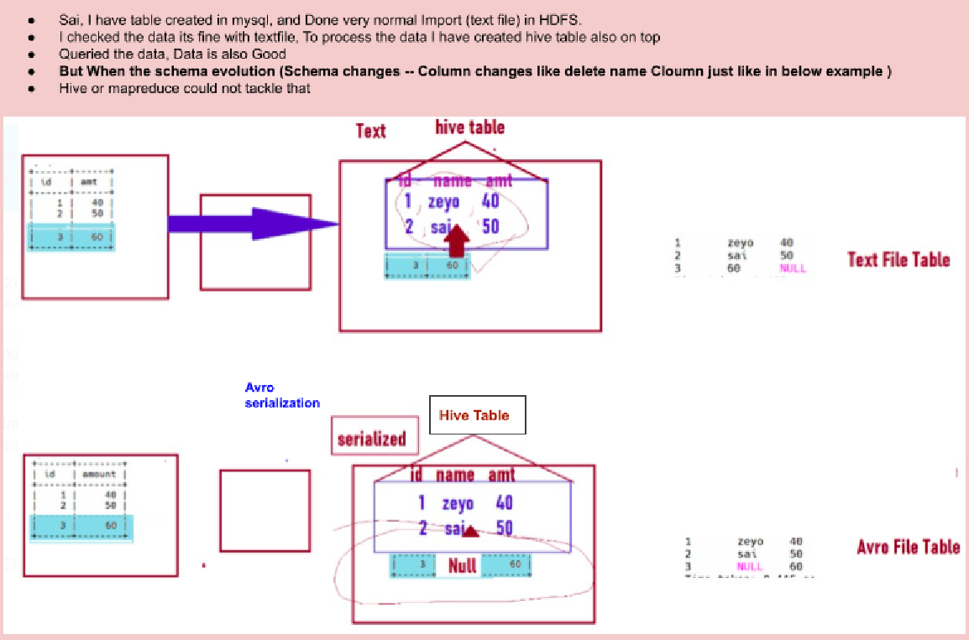

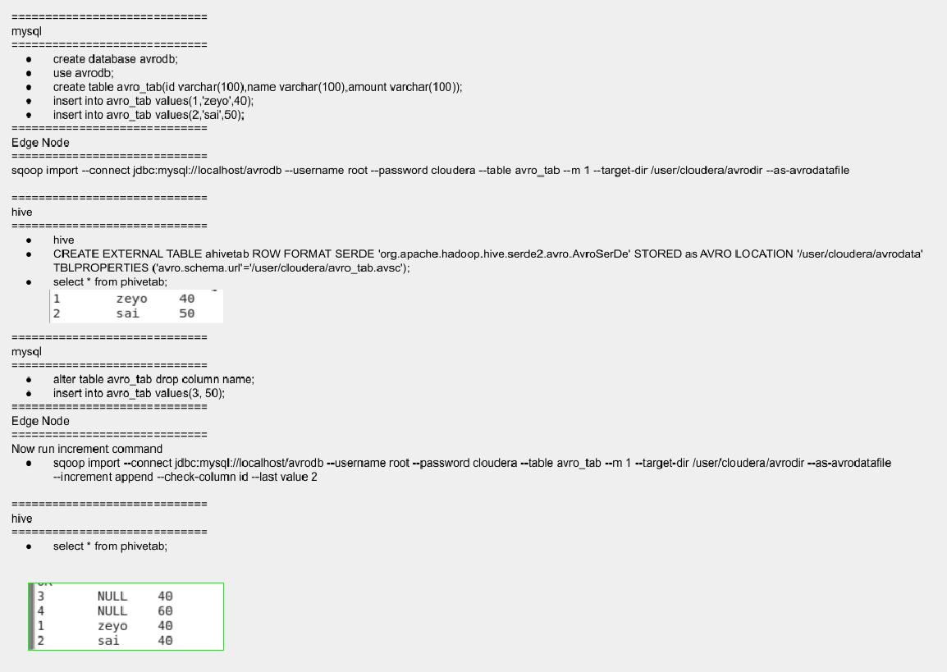

PARQUET - Came in 2012 by Doug Cutting, it is a very powerful ﬁle format yet
--as-parquetﬁle
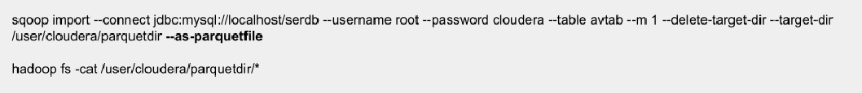
Features -

- Reduce compression from 60-80%
- It saves the ﬁle data in columnar ﬁle format
- Faster query ﬁle format
- Parquet uses Predicate pushdown mechanism
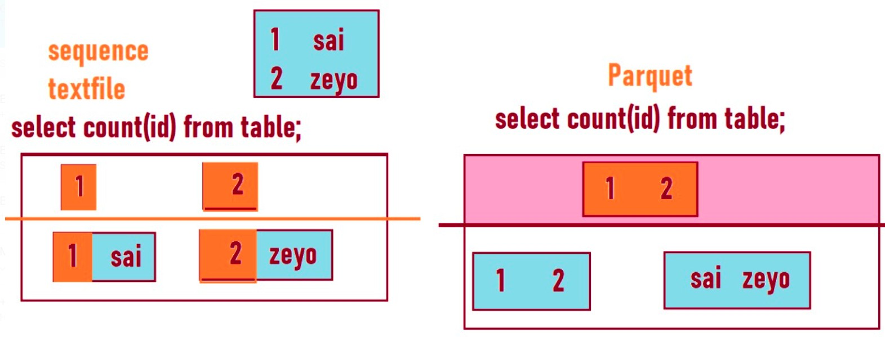

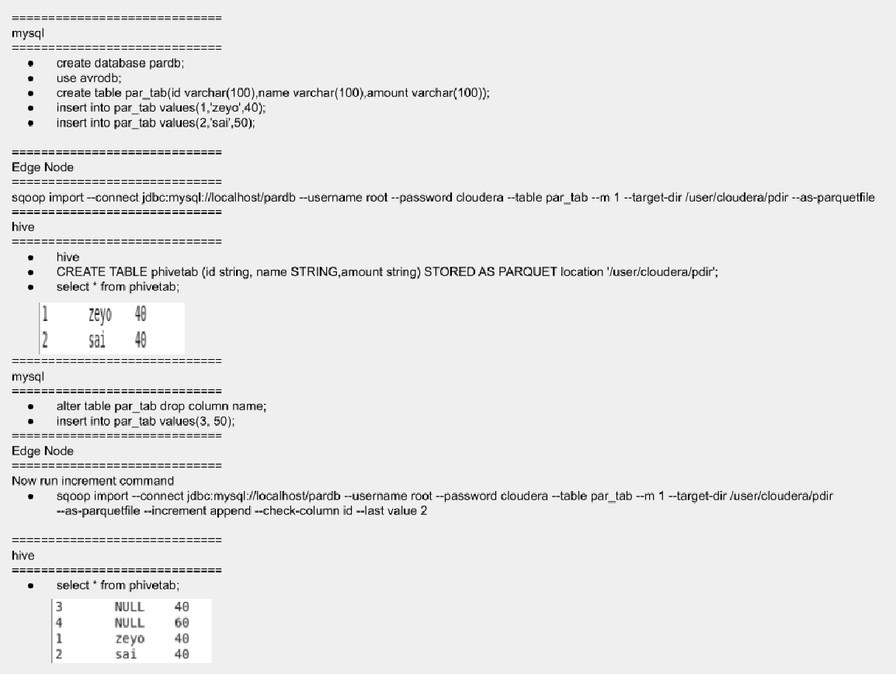

ORC (Optimized Row Columnar )-
We can not do SQOOP import for ORC

Features -
  - Compression rate is 90-95%
  - Query takes time because de-compression takes time
  - Historical Data
  - Columnar File
  - Faster but not much as Parquet ﬁle

Tasks/Interview questions

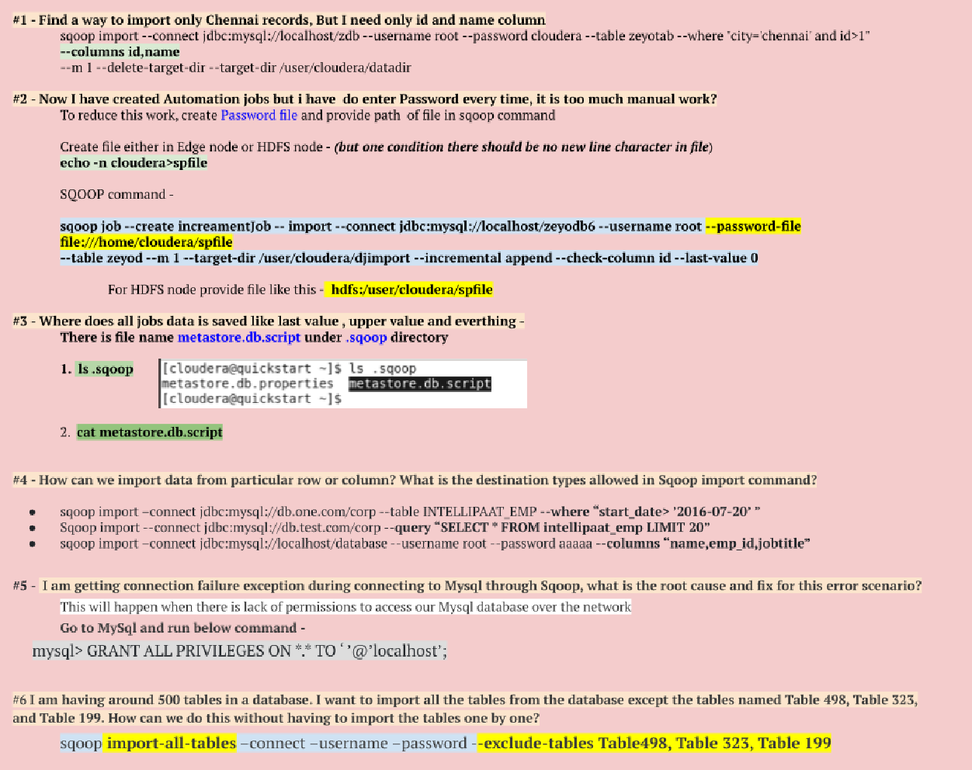

Multi-Mappers -
Multi-mapper is nothing but multi-threading. (Arg in sqoop ⇒ --m 1).

- We use multi-mapper to make imports faster
- If you want to increase mapper value(-- m 2) then you have to provide column value by adding an argument in command --split-by <columnName> or there should be a primary key in the table. If not provide any of these values then there will be an error like the below -

- By default, sqoop export uses 4 (--m 4)threads or number of mappers to export the data

  - 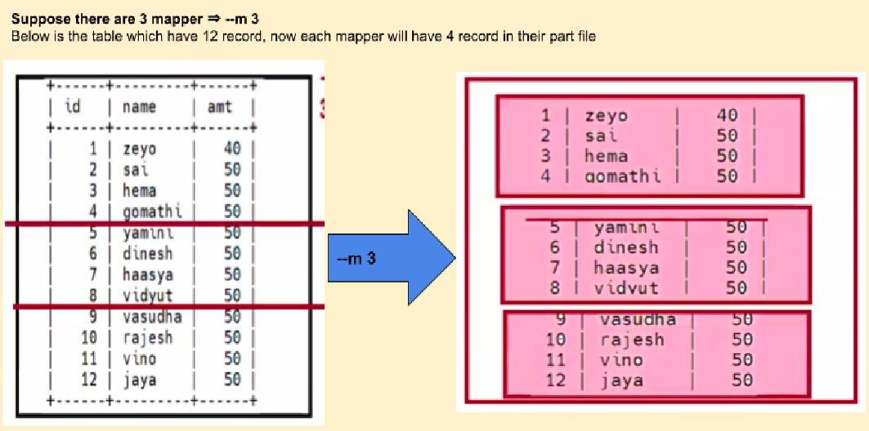For each mapper one separate part is created.

  - Mappers divide rows between multi-mappers using MIN and MAX values.

Performance Tuning By Mappers

In General, performance tuning in Sqoop can be achieved by:

  - Controlling Parallelism
    - Using Mappers
  - Controlling Data Transfer Process
    - Batching
    - Direct

Export in SQOOP -

Using SQOOP Export data to MySQL from HDFS
SQOOP EXPORT --connect jdbc://localhost/<dbName> --username root --password cloudera --m 1 \
--table <targetTableName> --staging-tab <stagingTable> --export-dir <dirPath>

Note - Here providing staging table(--stage-tab) role is “Data will export to Stage table ﬁrst then it will go to Target_table”, so that if the process couldn’t be completed due to any reason, we can easily delete data from the staged table.
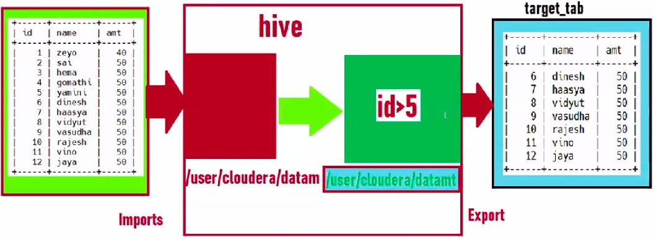

Using SQOOP move HDFS data to Hive Using SQOOP move MySql data to Hive Locations in Hive

Cloud -
Cloud is the usage of services. Few are the below services -

- EC2 (Elastic compute cloud) - It is for getting a virtual laptop
- RDS (Relational database system) - It is for storing RDBMS data
- S3 (Simple Storage service/Scalable Storage) - It is storage to store any data.
- EMR(Elastic Map Reduce) - For rent Hadoop system, EMR is group of nodes with hadoop install in it.

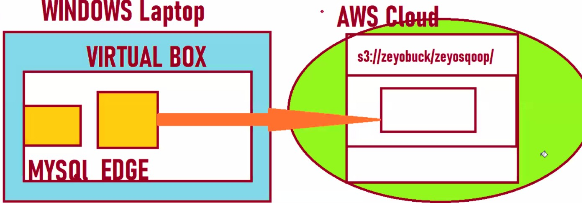
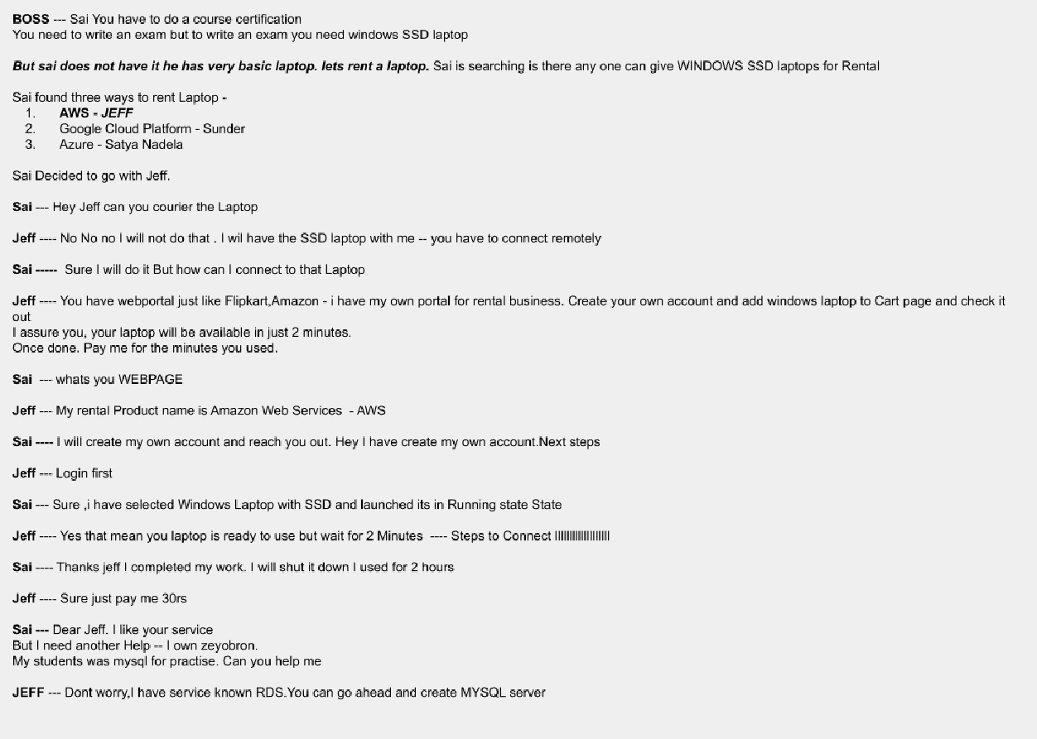

Cloud integration with SQOOP -
Command - Requires 3 arguments -
sqoop import
--Dfs.s3a.access.key=<accessKey>

--Dfs.s3a.secret.key=<SecertKey>
--Dfs.s3a.endpoint=<AWS-s3-endpiont>
--connect jdbc:mysql://localhost/dd2 --username root --password cloudera --table ztab
--m 1 --target-dir s3a://zeyobuck/zeyosqoop/Datadir
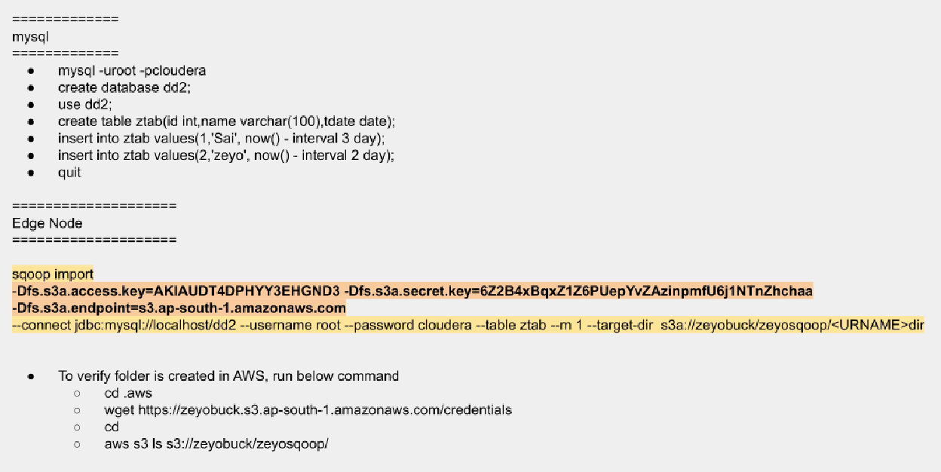
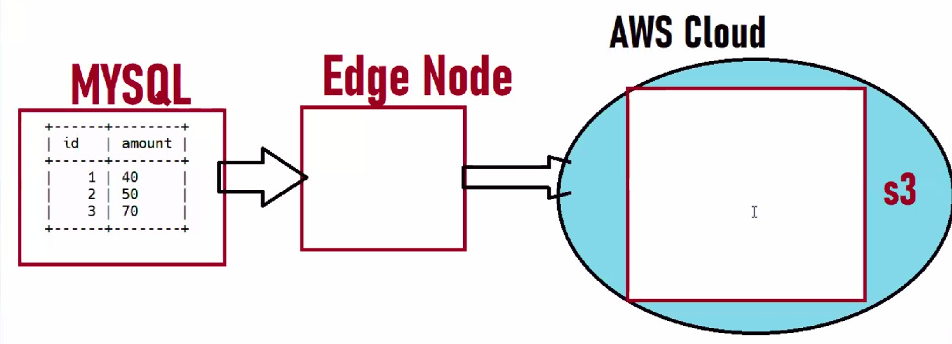

MapReduce

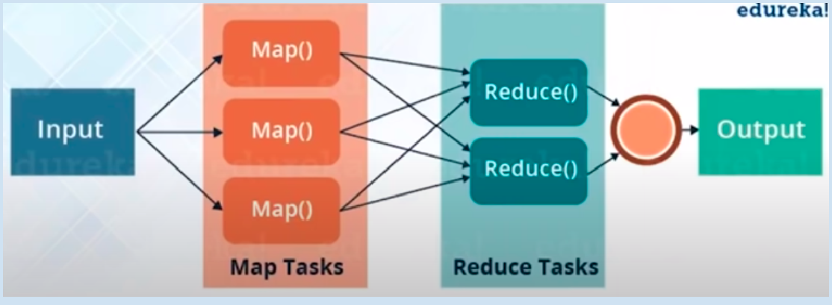

Components of MapReduce
- PayLoad: The applications implement Map and Reduce functions and form the core of the job
- MRUnit: Unit test framework for MapReduce
- Mapper: Mapper maps the input key/value pairs to the set of intermediate key/value pairs
- NameNode: Node that manages the HDFS is known as namednode
- DataNode: Node where the data is presented before processing takes place
- MasterNode: Node where the job trackers runs and accept the job request from the clients
- SlaveNode: Node where the Map and Reduce program runs
- JobTracker: Schedules jobs and tracks the assigned jobs to the task tracker
- TaskTracker: Tracks the task and updates the status to the job tracker
- Job: A program that is an execution of a Mapper and Reducer across a dataset
- Task: An execution of Mapper and Reducer on a piece of data
- Task Attempt: A particular instance of an attempt to execute a task on a SlaveNode

MapReduce Job workﬂow -

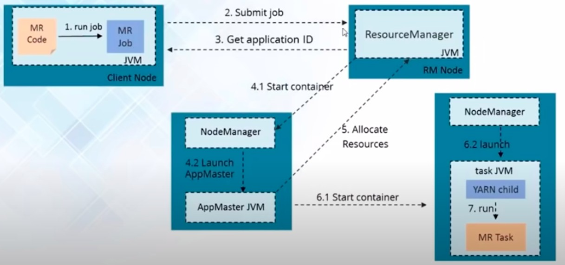

Abstraction of MapReduce -
- Hive - Query engine (uses SQL)
- Pig - yahoo invented
- Sqoop
- Oozie - yahoo invented use for automating/scheduling

HIVE -
Developed by JoyDeep Sen Sarma.

- Hive runs on top of HDFS. In simple, whatever we do in Hive there will be the same changes save in HDFS (dir ⇒ /user/hive/warehouse/)


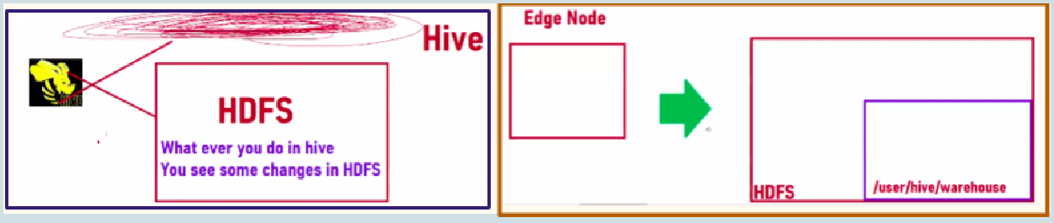

- Hive table should always be pointed to a location. While creating a table, please ensure to provide a directory Path to the table. If you do not specify any pointing directory, Hive will create a directory in the table's name and get pointed to it.
  - Check table Location - describe formatted <tableName>
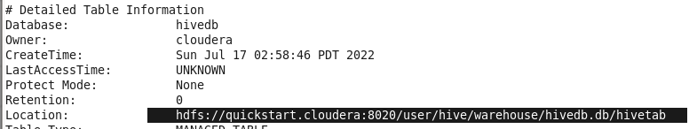

  - Location /user/hive/warehouse/ is the default hive location to store all tables and its data if the location is not provided. To provide Location, Read - Locations in Hive
- Apache Hive is a data warehouse system built on top of Hadoop and is used for analyzing structured and semi-structured data. Hive abstracts the complexity of Hadoop MapReduce. Basically, it provides a mechanism to project structure onto the data and perform queries written in HQL (Hive Query Language) that are similar to SQL statements. Internally, these queries or HQL gets converted to map reduce jobs by the Hive compiler. Therefore, you don’t need to worry about writing complex MapReduce programs to process your data using Hadoop. It is targeted towards users who are comfortable with SQL.

Why HIVE come?
- As Map-Reduce is made of JAVA. Earlier Map-Reduce code was difﬁcult to understand because java code wasn’t easy at that time.
- To process data in HDFS from one directory to another, you have to follow the below steps -
  - Should knowledge of JAVA
  - Should knowledge of Map-Reduce code

  - Do Tune Mappers
  - Do Tune Reducers
  - And then export it in JAR
  - Take that JAR to cluster and deploy it
- Then the Hive tool comes to eliminate the use of Map-Reduce, For HIve, you don't need any Java or Map-Reduce code (although in the backend it uses Map-Reduce).
- Hive looks like SQL but not SQL
- Easy to Work with it
- Hive internally uses MapReduce to process queries.
- Hive only replaces JAVA use, not MapReduce.
- Hive can on the top these 3 engines-
  - MapReduce
  - Tez
  - Spark

Hive Architecture
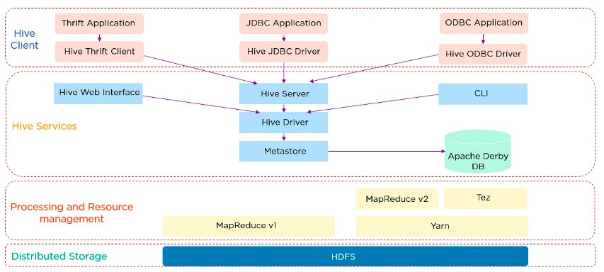

HIVE vs MySql

MySql | HIVE
Data storage for MySql is DATABASE | Data storage for HIVE is HDFS
E T L (Extracted Transform Load) - E ➺ T ➺ L Extracted - Extract de-serialize data Transform - Convert it into Serialized data Load - Then Load it in SQL  Run below command to Load data in MySql -  mysql> load data inﬁle 'ﬁlePath' into table <targetTableName> ﬁelds terminated by ',' ;  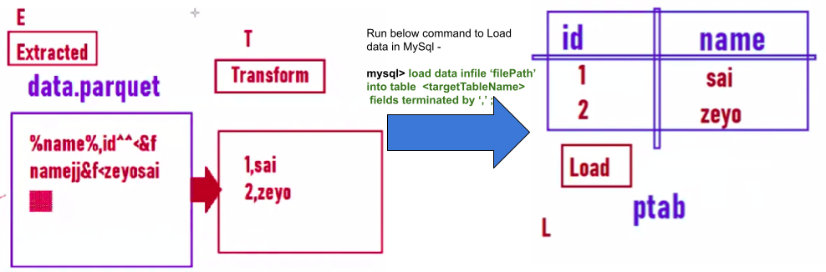 | E L T (Extracted Load Transform) - E ➺ L ➺ T  In Hive we just need to Extract data and run load command, Transform will take care By  HIVE.  Load - To Load data in Hive, Run below command to Load data in MySql -  hive> load data local inﬁle /user/cloudera/data.parquet into table '<targetTableName>;
Good for Small Data, for large data it is costly like server, nodes, set up, installation, license | Good and free for large data

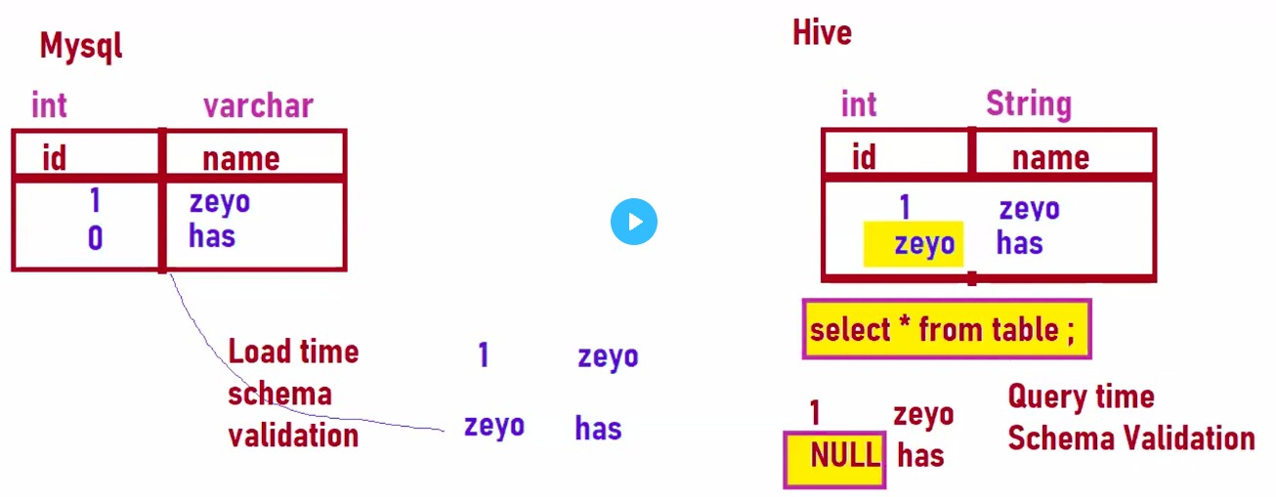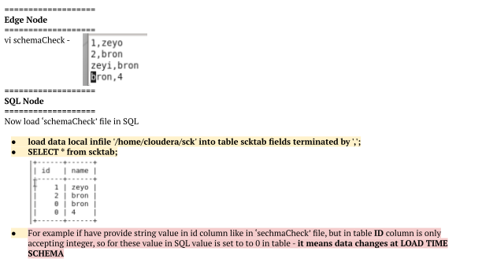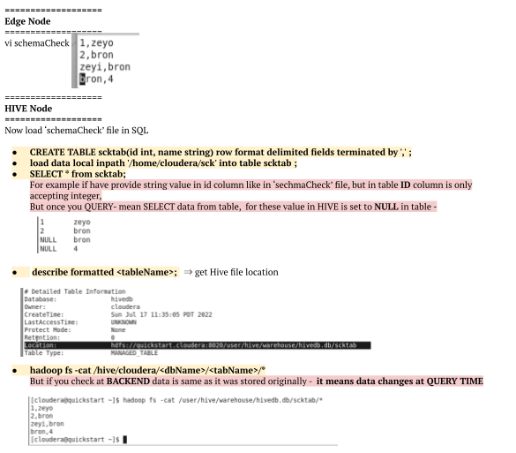

Load time schema validation (Schema on write)- once inserting data and changing the data type , data will set to 0 at load time. | Query time schema validation (Schema on Read)- once inserting data and changing the data type , there will be no change in data, But once you query the data it will give you NULL. But originally at backend data have same value that was provided during insert query.  Now after load and query data, get the location of table and check original data at backend  -  $ describe formatted <tableName>; ➺ get Hive ﬁle location  $ hadoop fs -cat /hive/cloudera/<dbName>/<tabName>/
SQL only query STRUCTURED data | Hive can query STRUCTURED, Semi-STRUCTURED data
SQL don’t have capability to query large data | Hive have capacity to only query PetaByte data

Type of Table in Hive -

MANAGED/Internal Table -
An internal table is a table that Hive manages. If you delete an internal table, both the deﬁnition in Hive and the data directory are deleted inside HDFS.
- CREATE TABLE IF NOT EXISTS Cars(Name STRING, id INT) ROW FORMAT DELIMITED
FIELDS TERMINATED BY ',' STORED AS TEXTFILE
LOCATION '/user/<username>/dataDir;

- Drop table Cars;

- Now if you Go to the location and check, directory won’t be there anymore
- Table created for Intermediate data processing, should be Managed type. So we can drop the table once the process is done.

EXTERNAL Table
An external table is a table for which Hive does not manage storage. If you delete an external table in Hive, only the deﬁnition in Hive is deleted. The data directory remains inside HDFS.
- CREATE EXTERNAL TABLE IF NOT EXISTS Cars(Name STRING, id INT) COMMENT 'Data about cars from a public database'
ROW FORMAT DELIMITED FIELDS TERMINATED BY ',' STORED AS TEXTFILE
LOCATION '/user/<username>/dataDir;

- Drop table Cars;

- Now if you Go to the location and check, the directory will be presented there
- Target table should always be EXTERNAL. Suppose if the table is deleted by mistake, it shouldn’t impact on target analytics data.

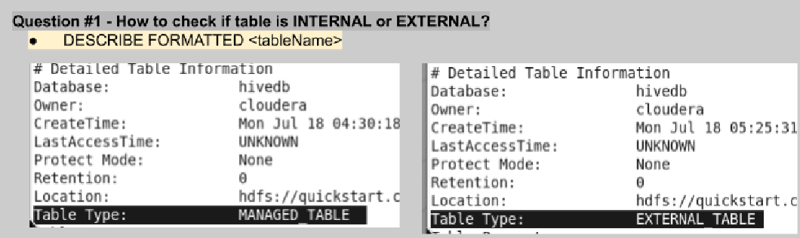

Load data from Edge Node into Hive
  - Create data file (text or .csv, etc) in EDGE node
2. CREATE TABLE table1(id int, name string) row format delimited fields terminated by ','; 3. LOAD DATA LOCAL inpath '/home/cloudera/<filePath>' into table <tableName>;

Load data from HDFS Node into Hive
1. Create data file (text or .csv, etc) in EDGE node
- Put data in HDFS - hadoop fs -put datacsv.csv /user/cloudera/datafiles
- CREATE TABLE tab(id int, name string) row format delimited fields terminated by ','; 4. LOAD DATA inpath '/home/cloudera/<filePath>' into table <tableName>;
Note - In step-4 after running the command ➺ data ﬁle will be moved to Hive location (/user/hive/warehouse/<dbName>.db/<tabName>) and CSV or text ﬁle will be removed from HDFS location. But once loading a ﬁle from EDGE, the data ﬁle will be copied instead of completely moving, so the data ﬁle remains at both locations EDGE nodes and
/user/hive/warehouse/…

Requirement #1 - Find a way to insert the above source tab data into another Hive table

- CREATE TABLE targetTab(id int, name string) row format delimited fields terminated by ',';
- INSERT INTO targetTab select * from tab where <condition>;

Using SQOOP move MYSQL data to Hive
To import data into Hive, below arguments are important -
hive-import
--create-hive-table
--hive-table HiveDatabase.hiveTableName

Sqoop Command Option | Description
--hive-import | Imports tables into Hive using Hive's default delimiters if none are explicitly set.
--hive-overwrite | Overwrites existing data in the Hive table.
--create-hive-table | Creates a hive table during the operation. If this option is set and the Hive table already exists, the job will fail. Set to false by default.
--hive-table <table_name> | Speciﬁes the table name to use when importing data into Hive.

If the database name is not provided in this argument --hive-table <tableName> then All data or tables which are imported from MySql will store in the DEFAULT database of Hive. You can ﬁnd a newly created table under the Default database.

  - Import table into Default database -
Below command will import MySql table to Hive into Default database
- sqoop import --connect jdbc:mysql://localhost/<dbName> --username root --password cloudera --table
<tableName> --m 1 --hive-import

  - Create table in hive then import SQL table data

sqoop import --connect jdbc:mysql://localhost/<dbName> --username root
--password cloudera --table <SqlTableName> --m 1
--hive-import --create-hive-table --hive-table hiveDB.<hiveTableName>

Note - A data ﬁle will be created under ‘/user/hive/warehouse/’ in the name of the Hive table.

  - We can import partition data, and incremental data as We do in SQOOP, just need to add the below values -
--hive-import --create-hive-table --hive-table <hiveTableName>

Using SQOOP move HDFS data to Hive
Below command will ﬁrst ingest Data from Mysql to HDFS ➺ Then created process-m-00000 ﬁle ➺ will process to Hive table
sqoop import --connect jdbc:mysql://localhost:3306/sqoop --username root --p cloudera --m 1 --table customer
--target-dir /user/cloudera/sqlToHdfsDir
--ﬁelds-terminated-by ","
--hive-import
--create-hive-table
--hive-table sqoop_workspace.customers

Locations in Hive
Suppose we are processing data like that -> HDFS ➺ Source Table ➺ Target Table

Requirement #1 - Find a way to process only speciﬁc data from HDFS to Target table but ensure do not use Source Table(As you did here - Requirement #1 - Find a way to insert above tab data into another Hive table)

    - 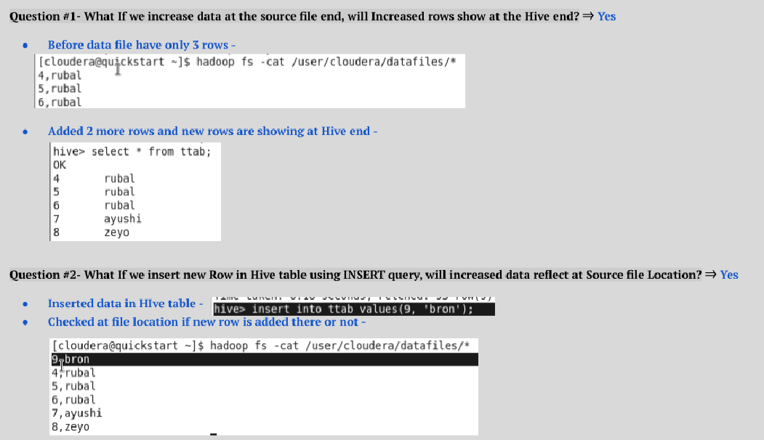While creating the table provide the location directory where your data is stored, and once you query the table it will show you data.
CREATE EXTERNAL TABLE IF NOT EXISTS Cars(Name STRING, id INT) ROW FORMAT DELIMITED
FIELDS TERMINATED BY ',' STORED AS TEXTFILE
LOCATION '/user/<username>/dataDir;

    - And once you query the table it will show you data. SELECT from cars;

Hive File Formats

Load Text Data to Hive
create table avroTab(id int, name string) row format delimited ﬁelds terminated by ‘,’ LOCATION '/user/cloudera/project1';

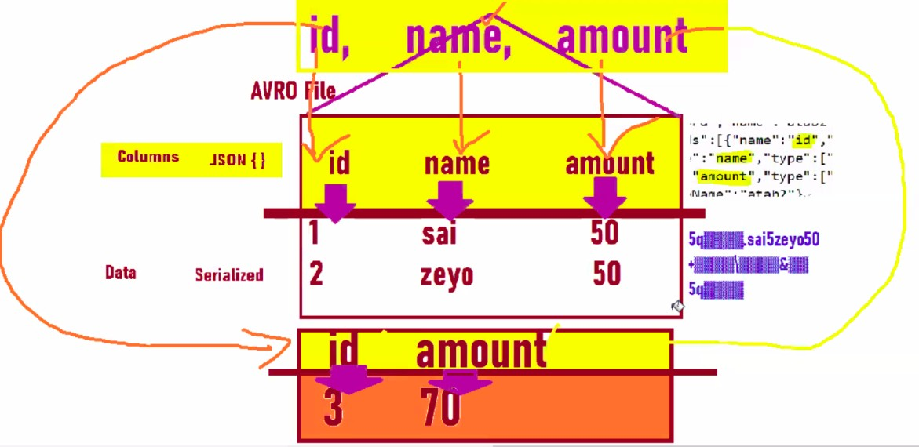

- Load AVRO Data to Hive
create table avroTab row format
SERDE 'org.apache.hadoop.hive.serde2.avro.AvroSerDe' STORED AS AVRO LOCATION '/user/cloudera/project1' TBLPROPERTIES ('avro.schema.url'='/user/cloudera/customer.avsc');
For more Practice refer Phase 1 - Project

- AVRO supports schema evolution
- AVRO ﬁle has two sections ➺ JSON schema and serialized data
- Since data has columns coupled, since which columns we call it gets fetched from File
- When you create a hive table for avro data, you cannot specify column names. Instead you need AVSC ﬁle to be available

3. Load Parquet Data to Hive
- sqoop import --connect jdbc:mysql://localhost/pdb1 --username root --password cloudera --table par_tab --m 1 --target-dir
/user/cloudera/pdir --as-parquetﬁle
- CREATE TABLE hiveTab (id STRING, name STRING) STORED AS PARQUET location '/user/cloudera/pdir';

4. Load ORC Data to Hive

We can not upload data in ORC table using ‘load data inpath’ (because there is no SQOOP import for ORC). If we want to load data in ORC table we have to use the ‘insert into or insert overwrite’ command.
- CREATE TABLE IF NOT EXISTS mycars(id INT, Name STRING) ROW FORMAT DELIMITED
FIELDS TERMINATED BY ','
STORED AS ORC;
- INSERT INTO orcTab SELECT * FROM targetTab;
— or —
INSERT OVERWRITE orcTab SELECT * FROM targetTab;

Hive Data Modeling
That was how data ﬂows in the Hive. Let's now take a look at Hive data modeling, which consists of tables, partitions, and buckets:
- Tables - Tables in Hive are created the same way it is done in RDBMS
- Partitions - Here, tables are organized into partitions for grouping similar types of data based on partition key
- Buckets - Data present in partitions can be further divided into buckets for efﬁcient querying

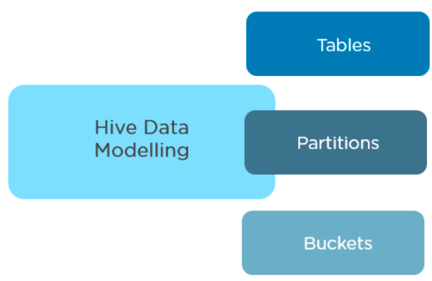
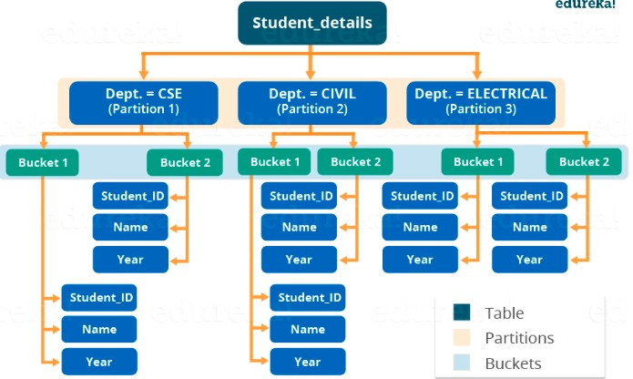

Partitions -
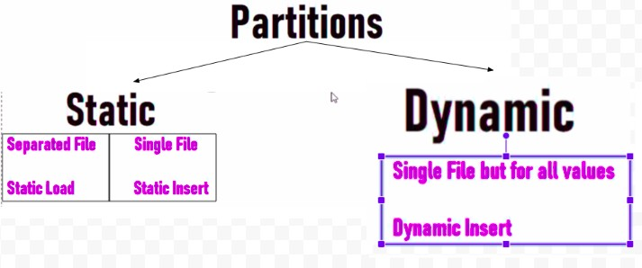

Static Partition -

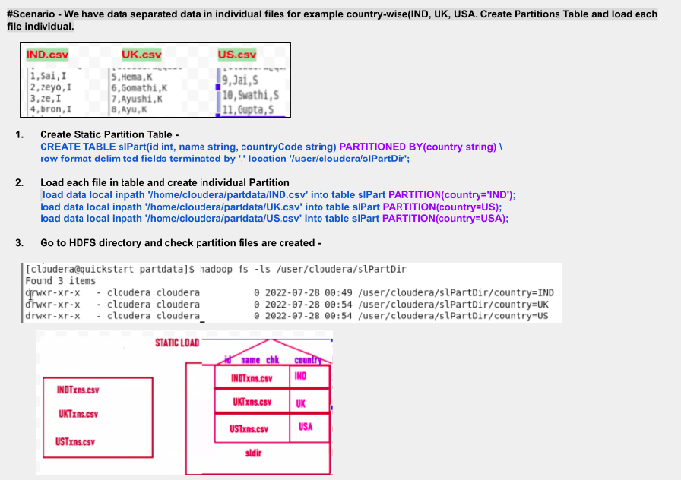

  - Static Load -
- CREATE TABLE slPart(id int, name string) PARTITIONED BY(country string)
ROW FORMAT DELIMITED FIELDS TERMINATED BY ',';
- load data local inpath '/home/cloudera/partdata/IND.csv' INTO table slPart PARTITION(country='IND');

  - Static Insert -
- CREATE TABLE siPartTable(id int, name string) PARTITIONED BY(country string) ROW FORMAT DELIMITED FIELDS TERMINATED BY ',';
- INSERT INTO siPartTable PARTITION(country=’US’) SELECT id,name from dataTab WHERE country=’US’;

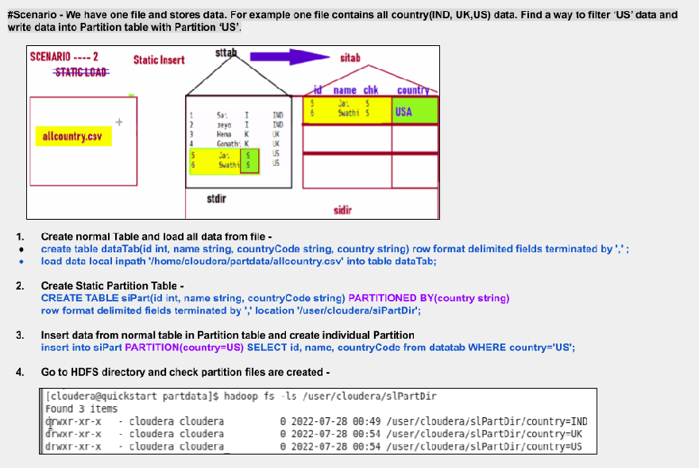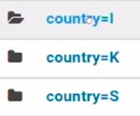

2. Dynamic Partition -
- CREATE TABLE dynPartTable(id int, name string) PARTITIONED BY(country string) ROW FORMAT DELIMITED FIELDS TERMINATED BY ',';
- INSERT INTO dynPartTable PARTITION(country) SELECT id, name, country from dataTab;

Rules of Dynamic Partition -
  - The last column will be considered for creating dynamic partition ﬁles.
Like below, provided partition ‘country’ but the last column was countryCode -

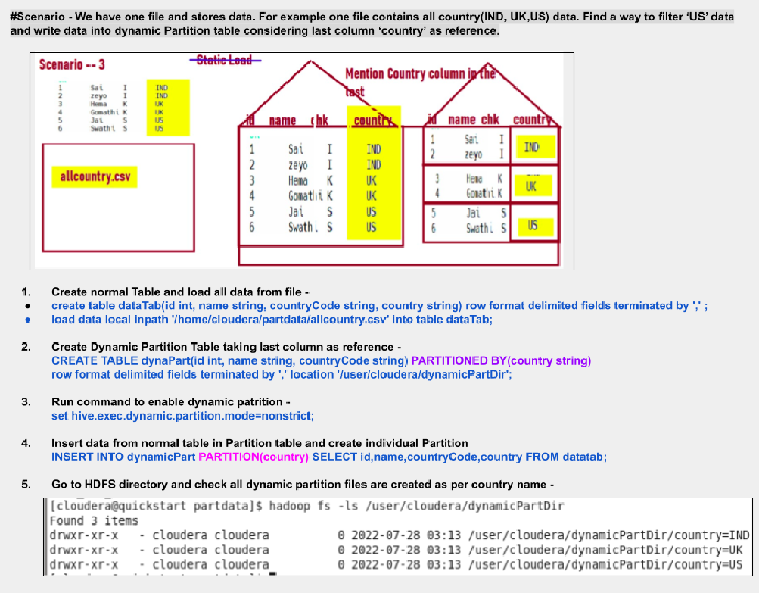

Bucketing
Sai Video - https://www.youtube.com/watch?v=WGATmuJTKGQ

- Analytics column is highly cardinal
- Joins are easy
- Good for Integer columns
- Reduces runs in this operations
- Bucketing is not folder creation, it’s ﬁle creation. 6. It use existing column to create buckets

- CREATE EXTERNAL TABLE part_Buck(no INT, name STRING, city STRING, state STRING)
PARTITIONED BY(country STRING) CLUSTERED BY(no) into 5 BUCKETS
row format delimited fields terminated by ',' location '/user/cloudera/partBucketData';

- / * Enable Partition and Bucketing property in HIve - */ set hive.enforce.bucketing=true;

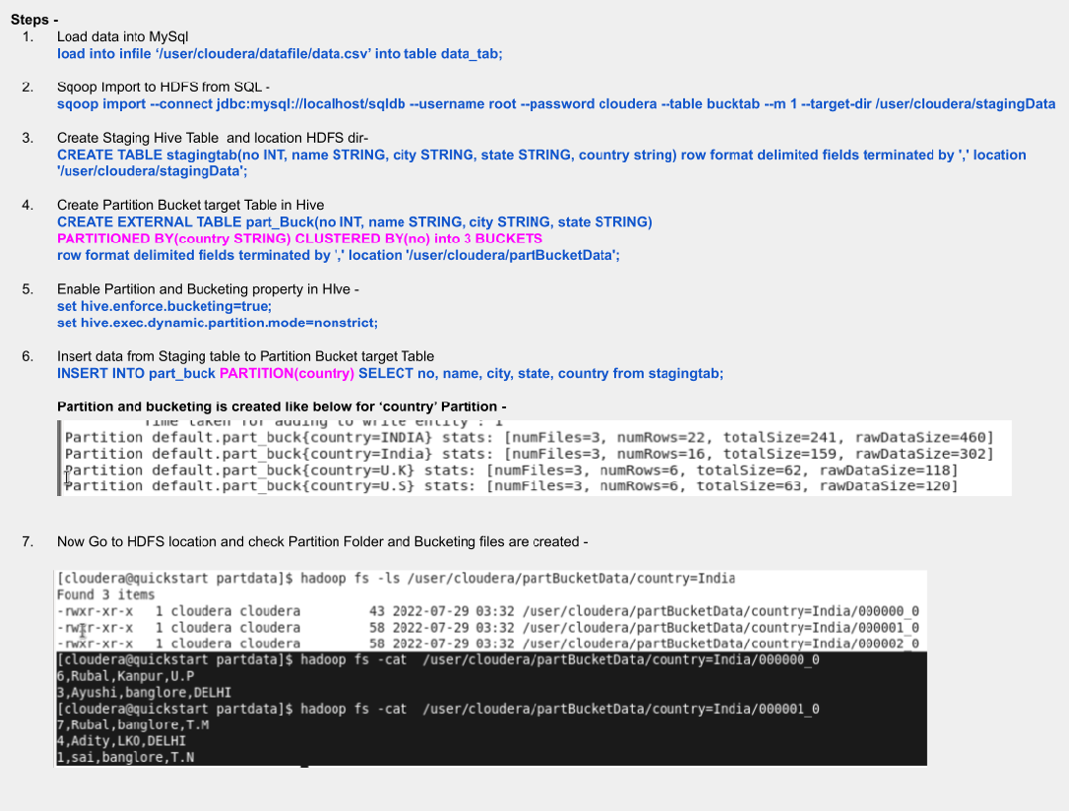

set hive.exec.dynamic.partition.mode=nonstrict;

3. / * Insert data from Staging table to Partition Bucket target Table */
INSERT INTO part_buck PARTITION (country) SELECT no, name, city, state, country from stagingtab;

How Bucketing decide which part ﬁle records will go

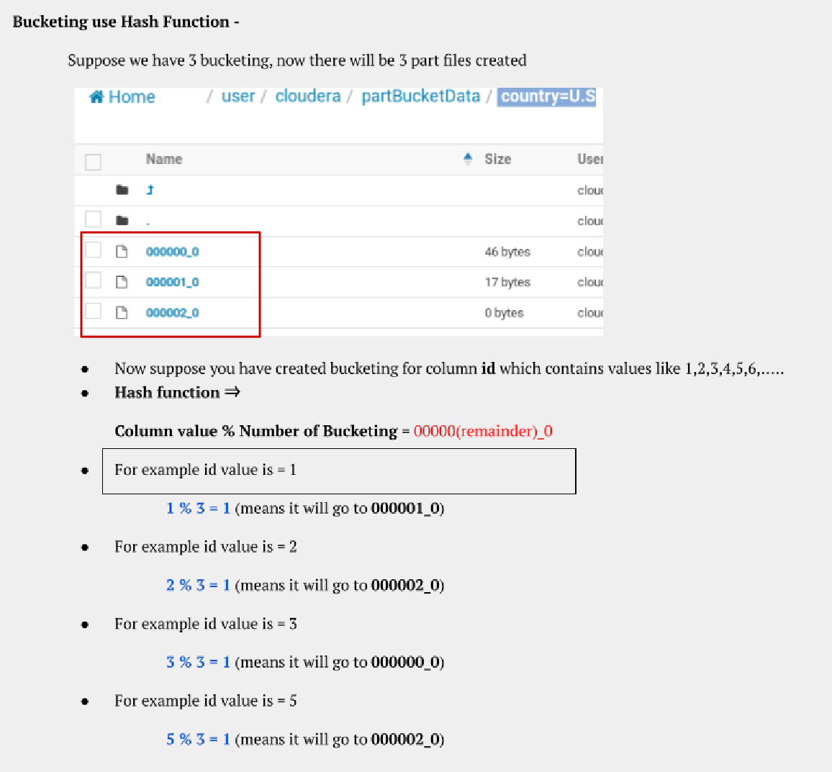

How to Decide [Bucket Count] in Hive
Youtube - https://www.youtube.com/watch?v=pHvyhfWK43s&list=PLLa_h7BriLH2kU021Tkxbn5N6 LhJp9dpu&index=8

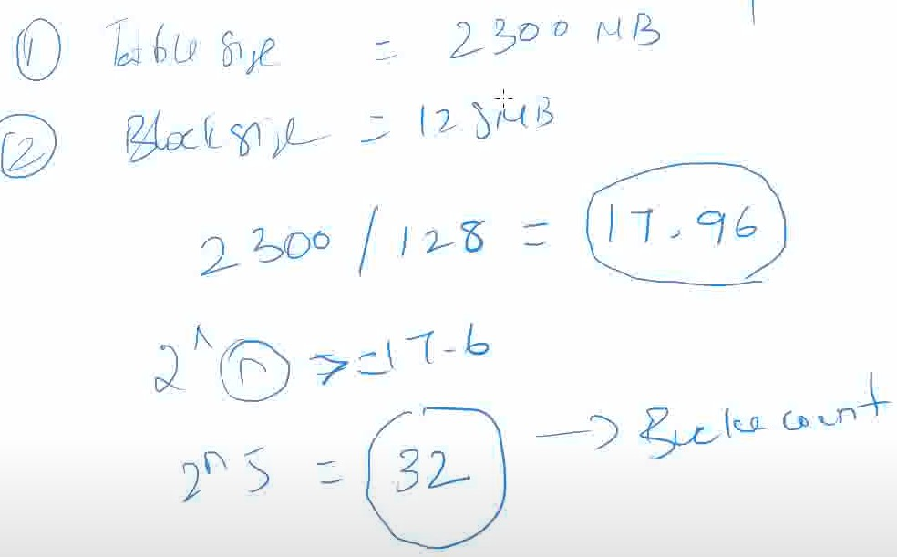
Partition Vs Bucketing

Partition | Bucketing
We decide which data have to go in which partition/folder | Here bucketing internally decides using a hash function which record will go in which ﬁle.
Partition creates folder and inside that folder we have part-m-00000 ﬁle | Bucketing creates part-m-00000 ﬁles as per number of buckets
- It provides faster query responses like partitioning.
- In bucketing due to equal volumes of data in each partition, joins at Map side will be quicker.
When to use Partitioning?  - When the column with a high search query has low cardinality. For example, if you create a partition by the country name then a maximum of 195 partitions will be made and these number of directories are manageable by the hive.  - On the other hand, do not create partitions on the columns with  very high cardinality. For example- product IDs, timestamp, and | When to use Bucketing?  - We cannot do partitioning on a column with very high cardinality. Too many partitions will result in multiple Hadoop ﬁles which will increase the load on the same node as it has to carry the metadata of each of the partitions.  - If some map-side joins are involved in your queries, then bucketed tables are a  good option. Map side join is a process where two tables are joined using the map function only without any reduced function. I would recommend you to go

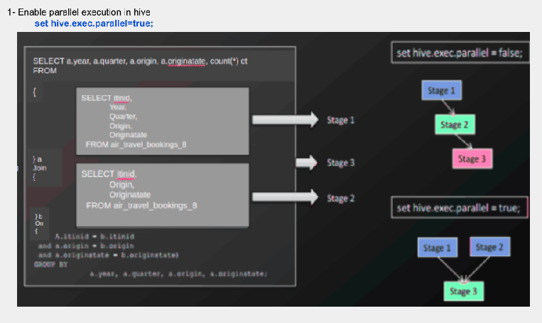
Hive Performance Tuning
- Partitioning
- Bucketing
- Parquet
- Parallel Execution
5. Vectorization
Usually hive considers only 1 row at a time to process but if you enable vectorization it would consider 1024 rows at a time to process but it kills a lot of memory and core
occupancy.
set hive.vectorization.execution.enable=true;

price because it will create millions of directories which will be impossible for the hive to manage.  - It is effective when the data volume in each partition is not very  high. For example, if you have the airline data and you want to calculate the total number of ﬂights in a day. In that case, the result will take more time to calculate over the partition “Dubai” as it has one of the busiest airports in the world whereas for a country like “Albania” will return results quicker. | through this article for more understanding about map-side joins.

- Map side join

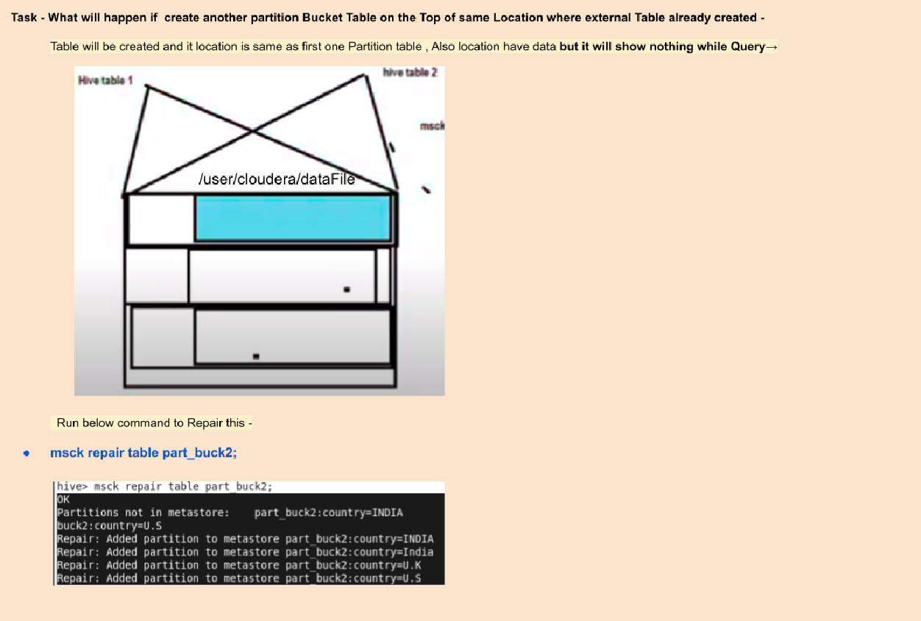

Phase 1 - Project
Phase 1 - Project
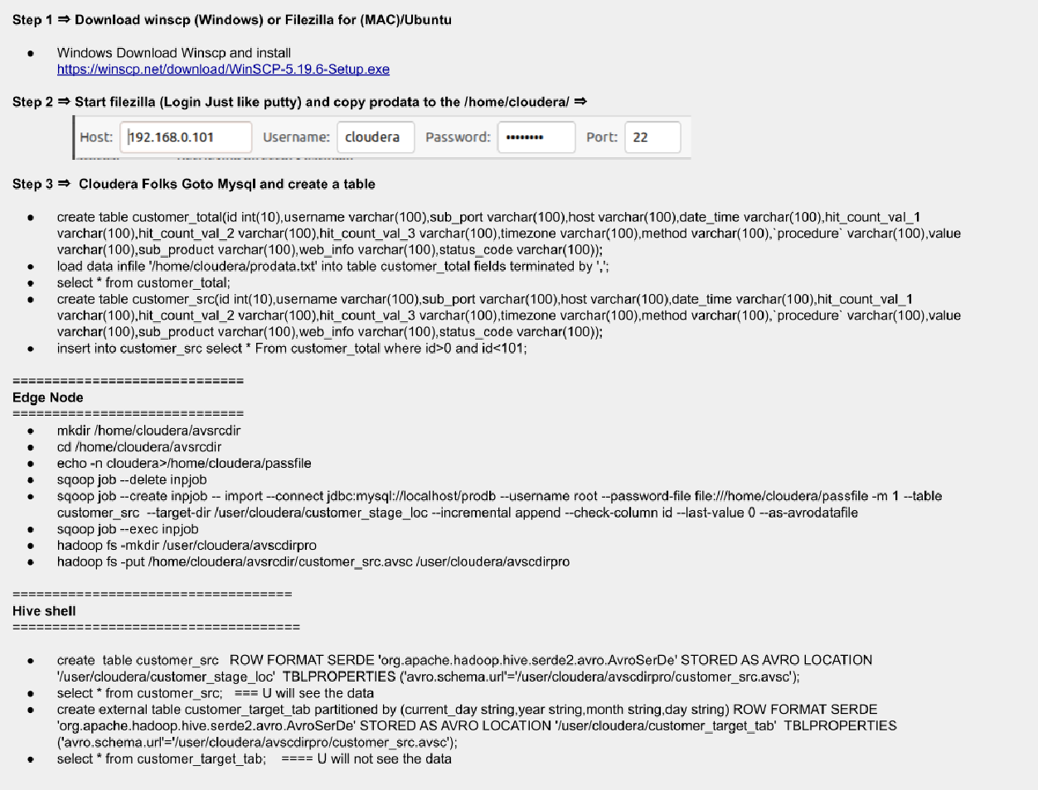

SPARK -
Invented by Matai Zaharia in 2010 but initially released by Apache in 2014.

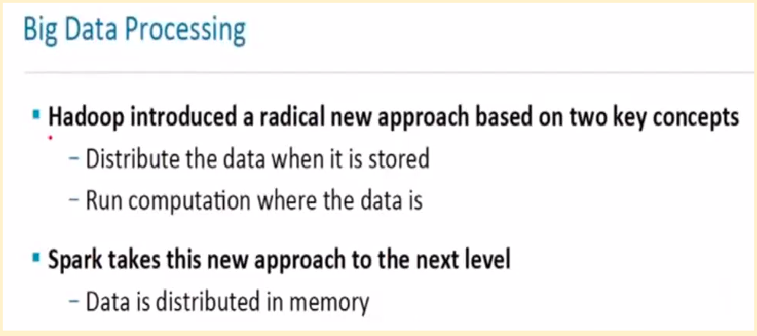

Spark Installation
  - Prerequisites ➺ Java and Scala

  - Download Java in case it is not installed using the below commands.
sudo apt-get install python-software-properties sudo apt-add-repository ppa:webupd8team/java sudo apt-get update
sudo apt-get install oracle-java8-installer
  - Download the latest Scala version from Scala Lang Ofﬁcial page. Once installed, set the scala path in the ~/.bashrc ﬁle as shown below.
export SCALA_HOME=Path_Where_Scala_File_Is_Located export PATH=$SCALA_HOME/bin:PATH
  - Download Spark from the Apache Spark Downloads page.

  - Extract Spark tar using the below command.
tar -xvf spark-2.1.0-bin-hadoop2.7.tgz

  - Set the Spark_Path in ~/.bashrc ﬁle.
export SPARK_HOME=Path_Where_Spark_Is_Installed export PATH=$PATH:$SPARK_HOME/bin

Spark set up with Scala and Run on Intellij

    - Make sure Java is installed on 8/11/17. (windows - Download winUtils and save in dir → D:/hadoop/bin/winutils.exe and set environment variable path)

      - HADOOP_HOME ➺ D:/hadoop
      - Update ‘Path’ variable with add a new path item there ➺
“%HADOOP_HOME%\bin”
    - Create Maven Project with Java
    - Install Scala Plugin in Intellij
    - Rename /src/main/java with /src/main/scala
    - Setup Scala SDK - Go to Project-structure in IntelliJ → Go to Libraries → Add Scala SDK → Click on APPLY and click OK
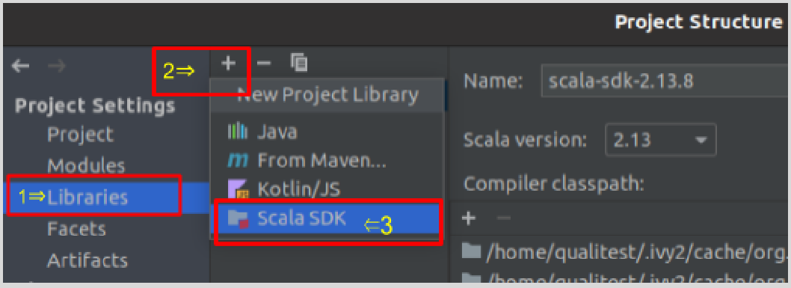

    - Add Spark Dependencies → Now either Add Spark Jar ﬁles
(spark-2.4.7-bin-hadoop2.7.tgz → jars folder ) or Add Spark Maven dependency in pom.xml
<dependency>
<groupId>org.apache.spark</groupId>
<artifactId> spark-core_2.12</artifactId>
<version>3.3.0</version>
</dependency>

<dependency>
<groupId>org.apache.spark</groupId>
<artifactId>spark-sql_2.12</artifactId>
<version>3.3.0</version>
<scope>compile</scope>
</dependency>

    - Create ﬁrst Scala Object under /src/main/scala
      - Right Click on /scala/ package and select New
      - Select Scala class
      - Give the object name and select scala object. Like the below image -

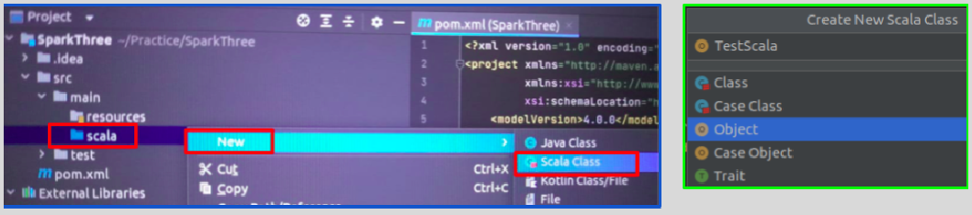

    - Run Maven Build → mvn clean install
    - Now run the Spark application SparkSessionTest program.
    - Run jar in Cloudera - spark-submit --class pack.test SparkThree-1.0-SNAPSHOT.jar

Why does Spark come into the Market?
- Hive used to satisfy only a few requirements.
- Hive runs on MR
- Hive is quite slow for very very very large data set
- Hive RUNS on HDFS ( No other platform)
- Hive No support on Streaming
- Hive no support on Machine Learning
- Hive cannot integrate with any sources to bring the data
- Hive is not customizable easily
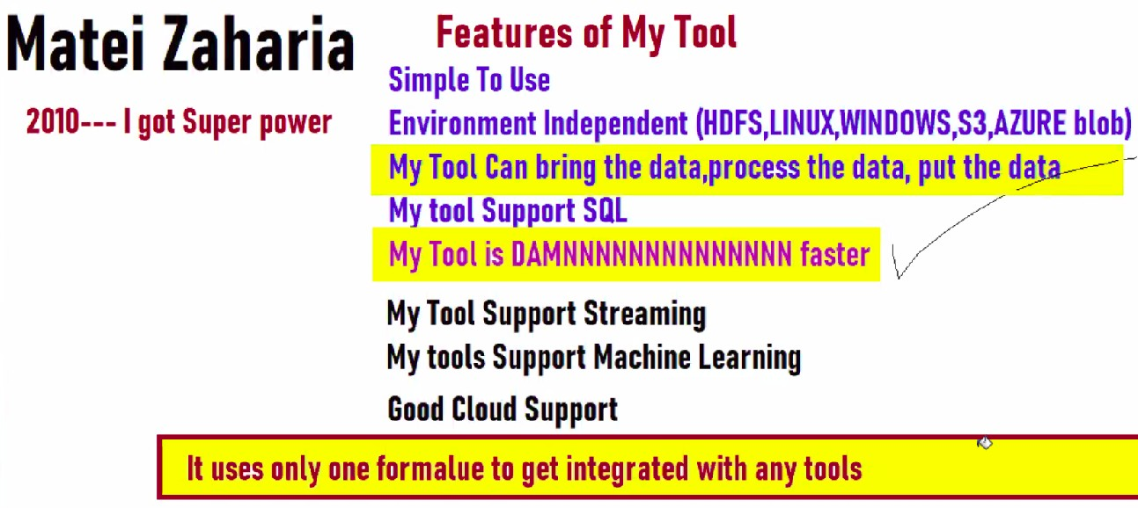

Advantages of Spark
- faster
- in-memory processing
- lazy computations
- environment independent
- MLV streaming
- Cloud Support
- Customization Serialization
- Uniﬁed Formulae
- GraphDB support
- SQL

Why is SPARK Faster?
  - Spark uses in-memory processing while MR(MapReduce uses I/O processing)
  - Lazy in nature - Once Action is triggered then only Transactions will run
    - Transaction 1 <=== Transaction 2 <=== Action
  - The lightning-fast performance due to its In-Memory Processing Capability brought Spark its place amongst the top-level Apache Projects.
●
●

Brief Introduction to Apache Spark
- Apache SparkTM is a fast and general engine for large-scale data processing framework for massive parallel computing (cluster)
- Harnessing the power of cheap memory
- Written using Scala, Java, and Python languages
- High-level APIs support in Scala, Java and Python
- Has had 36,338 commits made by 1,319 contributors. Representing lakhs of lines of code with proper comments.
- Developers from 50+ companies including UC Berkeley, Cloudera, Yahoo, Databricks, Intel, Groupon, etc., Apache Committers from 16+ organizations

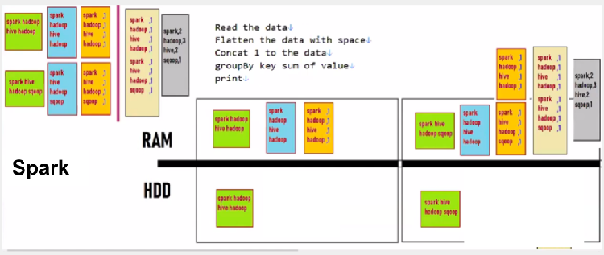
SPARK Vs MapReduce
Spark - In-Memory Processing example -
MR - I/O Processing example -
Transactions | Actions
Join | Count Select

Spark | MR
In-memory processing | I/O processing
Lazy evolution | Linear - Run steps one by one
Till the Action is triggered none of the Transaction will work. | Operation run step by step

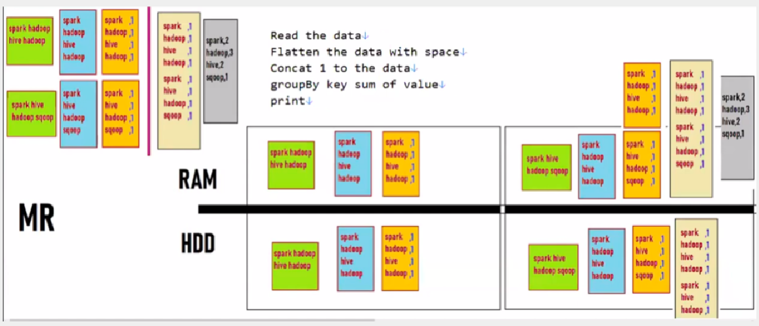
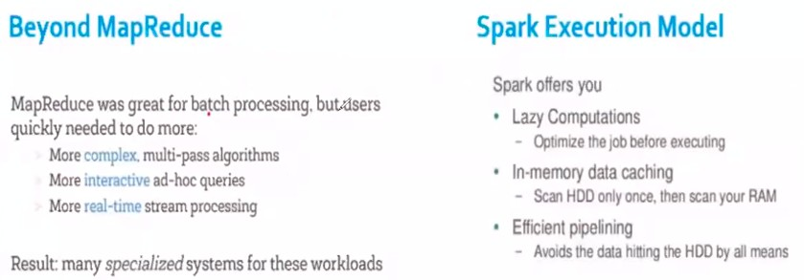

Pillars of Spark
Direct Acyclic Graph - sequence of computations performed on data

- Node - RDD partition
- Edge - transformation on top of data
- Acyclic - graph cannot return to the older partition
- Direct-transformation is an action that transitions data partition state (suppose from A node to B node)

Spark Internals

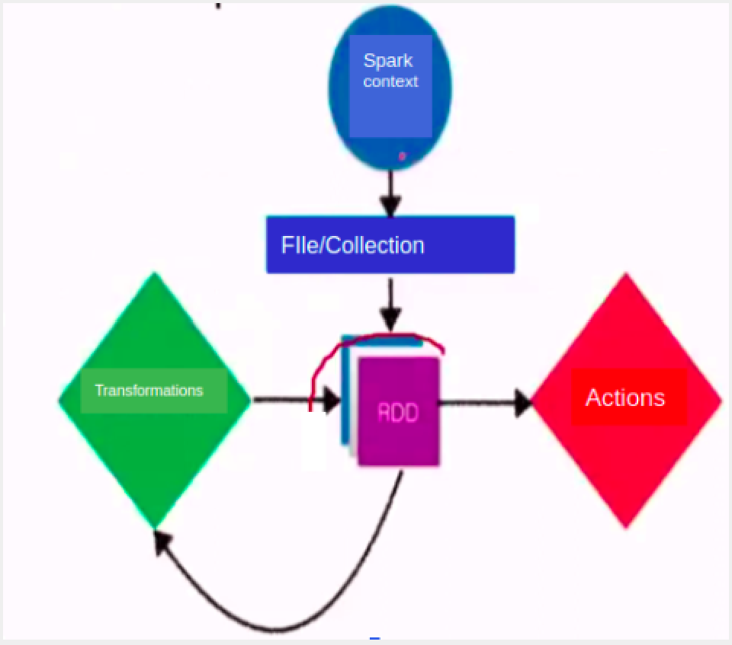

Spark Process the data in Two Ways
★ RDD and other one is Dataframe

RDD
- RDD means -
★ Resilient - if data in memory is lost, it can be recreated
★ Distributed - stored in memory across the cluster
★ Dataset - initial data can come from a ﬁle or be created programmatically
- RDDs are the fundamental unit of data in Spark
- Most Spark programming consists of performing operations on RDDs
- It is fault-tolerant if you perform multiple transformations on the RDD and then due to any reason any node fails. The RDD, in that case, is capable of recovering automatically.
- it does not have an optimizer like catalyst
- it is recommended to use a Data frame because of its performance

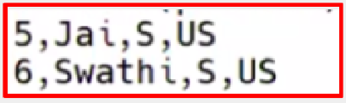

- it is available from 1.0 version
- For the RDD process, we need a jar “Spark-core.jar” which contains the class name “SparkContext” which has many methods like textFile(), ﬁlter, map(), ﬂatMap(), etc.
- To import ‘SparkContext’ in scala ﬁle write →import org.apache.spark.SparkContext

Below is the example of the RDD query and output -
- —---- open Spark shell —---
spark-shell

- sc.textFile("ﬁle:///home/cloudera/data.csv").ﬁlter(x => x.contains("US")).foreach(println)

======== How to Create SparkContext Object =============== import org.apache.spark.SparkContext
object SparkWordCount {
def main(args: Array[String]) {

/ “setAppName()” –> This is the name of the application that you want to run.
“setMaster()” --> This parameter denotes the master URL to connect the spark application to.
/
val conf = new SparkConf().setAppName("ﬁrst").setMaster("local[ ]")

/ Creating a [RDD] SparkContext Object /
val sc = new SparkContext(conf)

/ Read input ﬁle and store in variable /
val input = sc.textFile("input.txt")
val count = input.ﬂatMap(line ➺ line.split(" "))
.map(word ➺ (word, 1))
.reduceByKey(_ + _) count.saveAsTextFile("outﬁle")
}
}

- Use local[x] when running in Standalone mode. x should be an integer value greater than 0; this represents how many partitions it should create when using RDD,

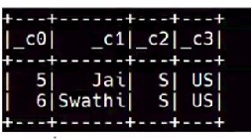DataFrame, and Dataset. Ideally, the x value should be the number of CPU cores you have.
RDD Advantages
  - In-Memory Processing
  - Immutability
  - Fault Tolerance
  - Lazy Evolution
  - Partitioning
  - Parallelize

DataFrame → SPARK SQL
★ It is conceptually a Row Columnar format
★ It has a optimizer like catalyst
★ It is available from 1.3 version
★ Can read and write different ﬁle formats
★ For the DataFrame process, we need a jar “Spark-sql.jar” which contains the class name “SparkSession” which has many methods like read(), ﬁlter, etc.
★ To import SparkSession in scala ﬁle write →import org.apache.spark.sql.SparkSession

Below is the example of the RDD query and output -
- spark-shell
- spark.read.csv("ﬁle:///home/cloudera/data.csv").ﬁlter("_C3='US'").show()

======== How to Create SparkContext Object ===============
import org.apache.spark.sql.SparkSession object SparkWordCount {
def main(args: Array[String]) {

/ SparkSession.builder() – Return SparkSession.Builder class. This is a builder for SparkSession. master(), appName() and getOrCreate() are methods of SparkSession.Builder.

“appName()” –> This is the name of the application that you want to run.
“master()” --> This parameter denotes the master URL to connect the spark application to.
/
Creating a [DataFrame] Spark Session Object /
var sparkSession = SparkSession.builder()
.master("local[1]")
.appName("SparkByExamples.com")
.getOrCreate();

/ Read input ﬁle and store in variable /
val input = sc.read.csv("input.csv")
}
}

RDD Vs DataFrame

RDD | DataFrame
Low Level —> If the requirement is small and easy, then RDD is a good choice. | High Level —> If the requirement is huge and big scenarios, then DF is a good choice. Like have semi-structured data
Support only Structured data | Support Structure and semi-structured
Through RDD, we can process structured as well as unstructured data. But, in RDD user need to specify the schema of ingested data, RDD cannot infer its own | In the data frame data is organized into named columns. Through dataframe, we can process structured and unstructured data efﬁciently. It also allows Spark to manage schemas.
Performance is slow as compared DF | Performance is faster as compared to RDD. DF has an inbuilt Tungston framework which makes DF to perform faster.
Less integration to read data from external source - It can only ready ﬁles, There are some extend to read data from Hbase, Hive, Cassandra, NoSQL but it is very very difﬁcult | Very good integration to read data from external source due to Uniﬁed formula (spark.read.format("csv").load("path"))

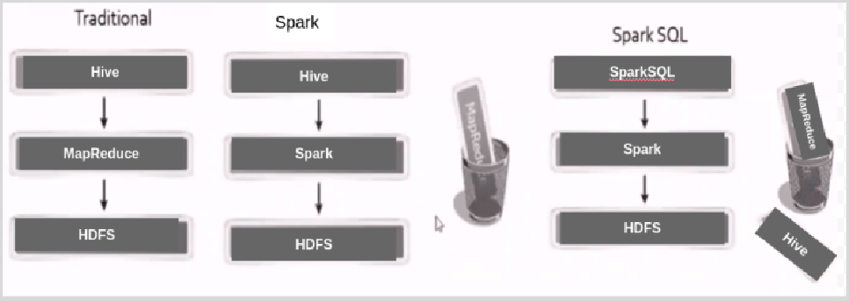

Evolution of Spark SQL

Scala programs
Practice more programs here - https://www.w3resource.com/scala-exercises/basic/index.php

Word Count Program
import org.apache.spark.SparkContext import org.apache.spark.SparkContext._ import org.apache.spark._

object SparkWordCount {
def main(args: Array[String]) {

/ “setAppName()” –> This is the name of the application that you want to run.
“setMaster()” --> This parameter denotes the master URL to connect the spark application to.
/
val conf = new SparkConf().setAppName("ﬁrst").setMaster("local[ ]")

/ Creating a [RDD] SparkContext Object /
val sc = new SparkContext(conf)

/ Read input ﬁle and store in variable /
val input = sc.textFile("input.txt")
val count = input.ﬂatMap(line ➺ line.split(" "))
.map(word ➺ (word, 1))
.reduceByKey(_ + _) count.saveAsTextFile("outﬁle")
}
}

# Program - How to use Filter, Map, FaltMap. Below is the List ➺
"Amazon-Jeff-America", ‘Microsoft-BillGates-America", ‘TCS-TATA-india",
‘Reliance-Ambani-INDIA"

Below are the operation to do on the above list ➺
    - Filter ‘india’ records (Ensure capital INDIA also ﬁltered)
    - Flatten(split) the result with Hyphen
    - Then replace “india” with “local” value
    - Then Concatenate “- Done" at the end of each item of the list then print it
object obj {

def main(args: Array[String]): Unit = {
var liststr = List("Amazon-Jeff-America", "Microsoft-BillGates-America",
"TCS-TATA-india",
"Reliance-Ambani-INDIA") println("String List ==> " + liststr)
var list2 = liststr.ﬁlter(x => x.toLowerCase().contains("india"))
.ﬂatMap(x => x.split("-"))
.map(x => x.replace("india", "local"))
.map(x => x.concat(", Done"))

println("ﬁlter list ==> ") list2.foreach(println)

===== OUTPUT ======
TCS- Done TATA- Done local- Done

Reliance- Done Ambani- Done INDIA- Done

# Write a Scala program to compute the sum of the two given integer values. If the two values are the same, then return triples of their sum.
package pack object obj2 {
def main(args: Array[String]): Unit={ print(sum(1,2))
print(sum(2,2))
print(sum(4,4))
}

def sum(i: Int, i1: Int): Int={
if (i == i1) (i + i1) * 3 else (i + i1)
}
}

RDD - Use Case #1
- Read the data file (data.csv) [just copy below data in a file]
- /*
first_name,last_name,company_name,address,city,county,state,zip,age,phone1,phone2,email,web James,Butt,"Benton, John B Jr",6649 N Blue Gum St,New
Orleans,Orleans,LA,70116,9,504-621-8927,504-845-1427,jbutt@gmail.com,http://www.bentonjohnbjr.com Josephine,Darakjy,"Chanay, Jeffrey A Esq",4 B Blue Ridge
Blvd,Brighton,Livingston,MI,48116,8,810-292-9388,810-374-9840,josephine_darakjy@darakjy.org,http://www.chanayjeffr eyaesq.com
Art,Venere,"Chemel, James L Cpa",8 W Cerritos Ave
#54,Bridgeport,Gloucester,NJ,8014,7,856-636-8749,856-264-4130,art@venere.org,http://www.chemeljameslcpa.com
*/
- Filter rows greater than which length > 200
- Flatten(split) the Filtered data with comma
- Replace hyphen with Nothing (Remove the Hyphen)
- Concat string →",zeyo" at the End of each element
- Store result in a file
=============================================================================

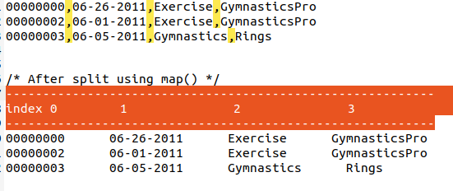

package pack
import org.apache.spark.{SparkConf, SparkContext} object obj1 {

def main(args:Array[String]): Unit={
val conf = new SparkConf().setAppName("Spark practice").setMaster("local[*]") val sc = new SparkContext(conf)

/* Read the data file */
var data = sc.textFile("file:///home/Practice/data/data.csv")

data = data.filter(x => x.length > 200) /* Filter rows greater than which length > 200 */
.flatMap(x => x.split(",")) /* Flatten(split) the Filtered data with comma */
.map(x => x.replace("-", "")) /* Replace hyphen with Nothing (Remove the Hyphen) */
.map(x => x.concat(" -> zeyo done")) /* Concat string →",zeyo" at the End of each element */ data.foreach(println)
/* Data write to a file (provide non-exist folder name in below)*/ data.coalesce(1).saveAsTextFile("file:///home/Practice/resultData")
}
}

RDD with DF- Use Case #2
- Read data from text ﬁle
- Split each column with comma like below

- Impose(create) schema using case class
- Convert it into schemaRDD
- Filter products(column/index 4) element contains “Gymnastics”
- Convert it into DataFrame

- Save result as Parquet
=======================================================================
Using SchemaRDD
=======================================================================
package pack
import org.apache.spark.sql.SparkSession
import org.apache.spark.{SparkConf, SparkContext} object obj1 {
case class schema(id: String, date: String, category: String, product: String) /* define schema using case class */ def main(args: Array[String]): Unit = {
val conf = new SparkConf().setAppName("spark practice").setMaster("local[*]")
val sc = new SparkContext(conf)

val data = sc.textFile("file:///home/Practice/data/datatxns.txt") val splitData = data.map(x => x.split(",")) /* split data */
/* Using SchemaRDD*/
val rddSchemaResult = splitData.map(x => schema(x(0), x(1), x(2), x(3))) /* convert data into schema(case class) */
.filter(x => x.product.contains("Gymnastics")) /* filter data */

println("====== RDD result for 'Gymnastics' product =======") rddSchemaResult.foreach(println)

println("====== Start DataFrame =======")
val ss = new SparkSession.Builder().getOrCreate() import ss.implicits._

val df = rddSchemaResult.toDF() /* convert rdd result into dataframe */
df.createOrReplaceTempView("filterTable") /* create sql view to perform more operation on data*/
val df_result = ss.sql("SELECT * from filterTable where date='06-26-2011'") /* run sql query on created view */

println("====== Filter more data using DataFrame =======") df_result.show() /* print data */
df_result.coalesce(1).write.parquet("file:///home/Practice/data/parquetData") /* save data in parquet file*/
}
}

Solution 2 → Run same able scenario but instead of using schemaRDD(case class) use Row rdd

- Step (1) & 2 is same as above solution
- After split data now CONVERT it to ROW rdd

- Filter products(column/index 4) element contains “Gymnastics”
- Impose(create) schema using StructType()
- Convert it into DataFrame
- Save result as Parquet
=======================================================================
Using RowRDD
=======================================================================
package pack
import org.apache.spark.sql.types.{StringType, StructField, StructType} import org.apache.spark.sql.{Row, SparkSession}
import org.apache.spark.{SparkConf, SparkContext}

object obj1 {
def main(args: Array[String]): Unit = {
val conf = new SparkConf().setAppName("spark practice").setMaster("local[*]") val sc = new SparkContext(conf)
val data = sc.textFile("file:///home/Practice/data/datatxns.txt") val splitData = data.map(x => x.split(",")) /* split data */
/* Using Row RDD*/
val rowData = splitData.map(x => Row(x(0), x(1), x(2), x(3))) /* convert data into Row rdd */
.filter(x => x(3).toString.contains("Gymnastics")) /* filter data */ println("====== RDD result for 'Gymnastics' product =======") rowData.foreach(println)
val structSchema = StructType(Array(
StructField("id", StringType, true),
StructField("date", StringType, true),
StructField("category", StringType, true),
StructField("product", StringType, true)
))

println("====== Start DataFrame =======")
val ss = new SparkSession.Builder().getOrCreate()
val df = ss.createDataFrame(rowData, structSchema) /* create frame using rdd data and struct schema */ df.createOrReplaceTempView("filterTable")
/* create sql view to perform more operation on data*/

val df_result = ss.sql("SELECT * from filterTable where date='06-26-2011'") /* run sql query on created view */

println("====== Filter more data using DataFrame =======") df_result.show() /* print data */
df.coalesce(1).write.parquet("file:///home/Practice/data/parquetData") /* save data in parquet file*/
}
}

Ways of Creating RDD
# 1. parallelizing data collection my_list = [1, 2, 3, 4, 5] my_list_rdd = sc.parallelize(my_list)

## 2. Referencing to external data file file_rdd = sc.textFile("path_of_file")

Ways of Create Dataframe

=======================================================
Create DataFrame from RDD
=======================================================
val columns = Seq("language","users_count")
val data = Seq(("Java", "20000"), ("Python", "100000"), ("Scala", "3000")) val rdd = sc.parallelize(data)
val dfFromRD1 = rdd.toDF() dfFromRDD.printSchema()

=======================================================
Using createDataFrame() with the Row type
=======================================================
val columns = Seq("language","users_count")
val data = Seq(("Java", "20000"), ("Python", "100000"), ("Scala", "3000")) val rdd = sc.parallelize(data)
val schema = StructType( Array(
StructField("language", StringType,true), StructField("users", StringType,true)

))
val rowRDD = rdd.map(x => Row(x._1, x._2))
val dfFromRDD = spark.createDataFrame(rowRDD,schema)
=======================================================
Using createDataFrame() from SparkSession
=======================================================
val columns = Seq("language","users_count")
val data = Seq(("Java", "20000"), ("Python", "100000"), ("Scala", "3000")) val rdd = sc.parallelize(data)
var dfFromData = spark.createDataFrame(data).toDF(columns:_*)
Read data from CSV/TEXT/JSON/Parquet/ORC (These ﬁle type are supported by Spark by default)
val df = spark.read.csv("/src/resources/file.csv") val df = spark.read.text("/src/resources/file.txt") val df = spark.read.json("/src/resources/file.json")
val df = spark.read.format("csv").options("header", true).load("file:///C:/data/datatxns.txt") val df = spark.read.format("json").load("file:///C:/data/devices.json")
val df = spark.read.format("orc").load("file:///C:/data/data.orc")
val df = spark.read.format("parquet").load("file:///C:/data/data.parquet")
Read data from Avro
(need to add jara or dependency –> spark-avro_2.12)
===========================================================================
val df = spark.read.format("avro").load("file:///home/Practice/data.avro")
===========================================================================
Read data from XML
(need to add jara or dependency –> spark-xml_2.12)
===========================================================================
val df = spark.read.format("xml")
.option("rootTag", "POSLog")

.option("rowTag", "Transaction")
.load("file:///home/Practice/data/transactions.xml")

—------ Below is xml —----------
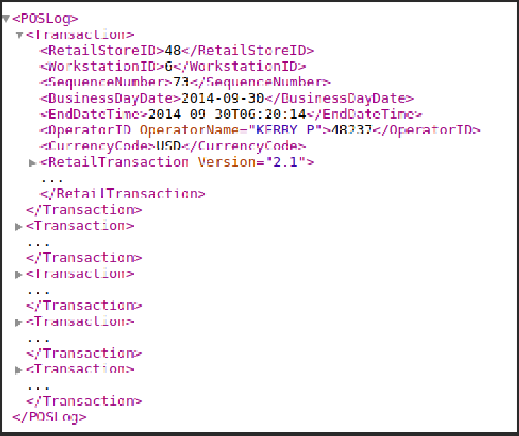

Read data from RDBMS Database
(need to add jara or dependency –> mysql-connector-java)
=======================================================
val df_mysql = spark.read.format("jdbc")
.option("url", "jdbc:mysql://localhost:port/db")
.option("driver", "com.mysql.jdbc.Driver")
.option("dbtable", "tablename")
.option("user", "user")
.option("password", "password")
.load()
Read data from AWS s3 location ﬁle
(need to add jara or dependency –> aws-java-sdf)
=======================================================
/* Read file from AWS S3 location */

val df = spark.read.format("csv")
.option("header", true)
.option("fs.s3a.access.key", "access-key")
.option("fs.s3a.secret.key", "secret-key")
.load("s3a://zeyodevbb/datatxns.txt") df.show()
Read data from Hive Table
====================================
val df = sparkSession.read
.options(Map(HBaseTableCatalog.tableCatalog -> catalog))
.format("org.apache.spark.sql.execution.datasources.hbase")
.load()

Spark File Mode/ Write ﬁle in Spark

There are 4 modes → error(default), append, overwrite, ignore
===============================================================
Write new data in existing folder but remove all old data files
===============================================================
object obj {
def main(args: Array[String]): Unit = {
val conf = new SparkConf().setAppName("practice").setMaster("local[*]") val sc = new SparkContext(conf)
val spark = SparkSession.builder().getOrCreate()

val data = spark.read.orc("file:///home/Practice/data/devices.csv") data.createOrReplaceTempView("dataView")
val filterData = spark.sql("SELECT * from dataView where lat>40")

/* 1st way to create write orc file */
filterData.write.mode("overwrite").orc("file:///home/Practice/data/d1")

/* 2nd way to create write orc file */ filterData.write.format("orc")
.mode("overwrite")
.save("file:///home/Practice/data/d2")

}
}
================================================================
Write/Add new data in existing folder but also keep all old data
=================================================================
filterData.write.format("orc")
.mode("append")
.save("file:///home/Practice/data/d2")
=======================================================================
Write new data in folder but if folder already exists don’t write data
======================================================================
filterData.write.format("orc")
.mode("ignore")
.save("file:///home/Practice/data/d2")

Create Partitioned data using scala?
/* Read file form Local */
val df = spark.read.format("csv").option("header", true)
.load("file:///home/Practice/data/usdata.csv")

/* data Partition by 'state' */
df.write.format("csv").partitionBy("state")
.mode(SaveMode.Overwrite).save("file:///home/Practice/data/Partition_1.csv")

/* data Partition by 'state' and "country" */
df.write.format("csv").partitionBy("state", "county")
.mode(SaveMode.Overwrite).save("file:///home/Practice/data/Partition_2.csv")

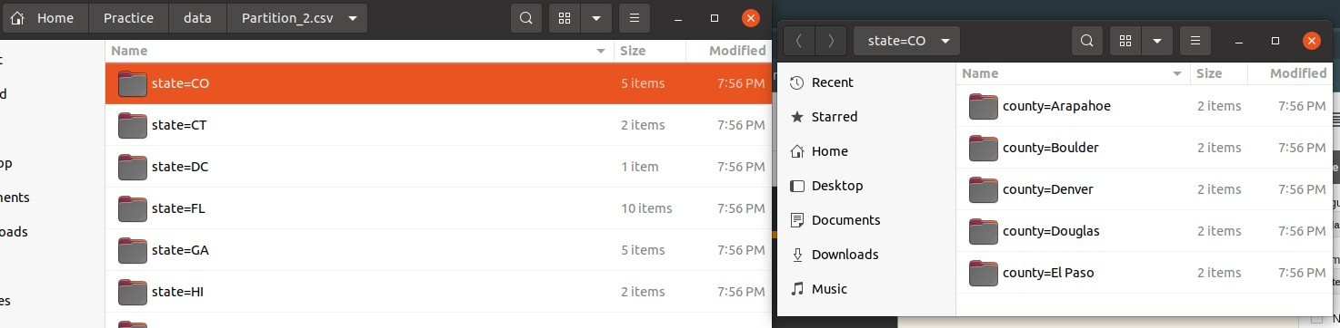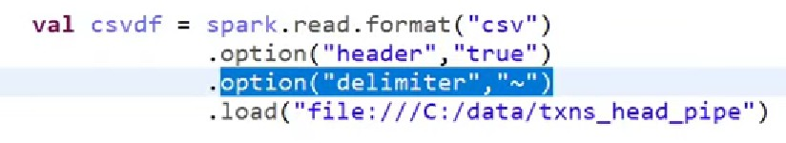

Options use cases

Delimiter - it will split data from that ‘~’ into columns

Spark SQL
  - Read data from the ﬁle and save it in variable
  - Create SQL view (the view is like a table for temporary to execute options that should not affect the original table)
  - Run SQL command using spark.sql(command) on that view just like a table.

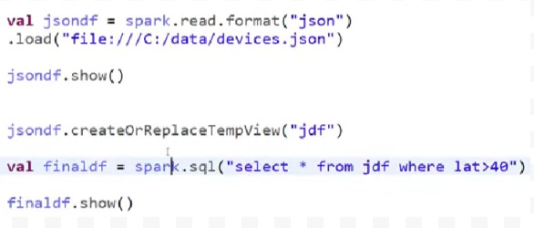

Spark DSL(Domain speciﬁc language)

Filters with column conditions and operations
To run any operation over any column value, use col(columnName) to take columns from data.
val df = spark.read.format("csv").option("header", value = true)
.load("file:///D:/BigData/data/dt.txt")

println("======= Or '||' filter ========") df.filter(col("category") === "Exercise"
|| col("spendby") === "cash").show()

println("======= And '&&' filter ========") df.filter(col("category") === "Exercise"
&& col("spendby") === "cash").show()

println("======= Multi value filter ========") df.filter(col("category") isin ("Exercise", "Gymnastics")).show() println("======= not in Multi value filter ========") df.filter(!(col("category") isin ("Exercise", "Gymnastics"))).show()

println("======= 'like' operator using filter ========") df.filter(col("product") like "%Gymnastics%").show()

println("======= 'null' value filter ========") df.filter(col("id") isNull).show()

println("======= not 'null' value filter ========") df.filter(col("id") isNotNull).show()

//SQL Expression
df.filter("gender == 'M'").show(false)

//Array condition - array_contains() is inbuilt SQL pack function df.filter(array_contains(df("languages"),"Java")).show(false)

//Struct condition
df.filter(df("name.lastname") === "Williams").show(false)

Few below alternatives for filter the column where “state” is column name
—

df.filter('state’ === "OH").show() df.filter($state === "OH").show() df.filter(col("state") === "OH").show()
df.where(df("state") === "OH").show()
df.where('state’ === "OH").show() df.where($state === "OH").show() df.where(col("state") === "OH").show()

withColumn use case
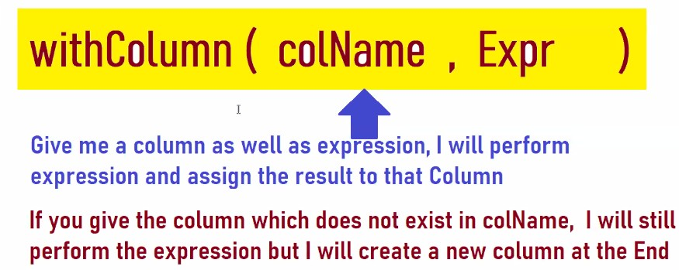
- To run the condition on only one condition and without bothering other columns use this method, as the result expression will run on only that column and all other columns will also be in the result with any change.
- For example, using selectExpr() we have to give all column names that exist in the table with the expressional column, using withColumn we can reduce that work.

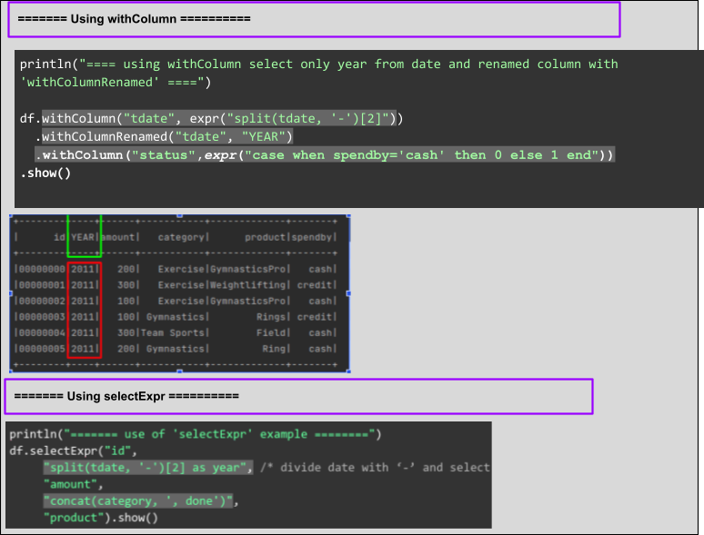

- If in colName value ‘column’ exist in table than expression value will be override otherwise if column not exist but expression is correct new column will be created in the end of table with expressions value, like below -
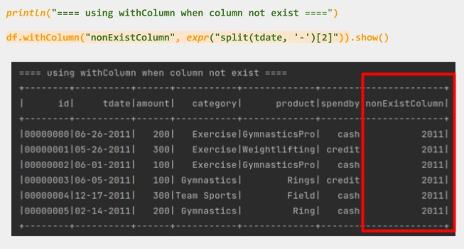

DSL Functions Queries
println("=== GroupBy and Aggregate method use ====")

/* find total amount of category */ df.groupBy("category")
.agg(sum("amount").as("Total Amount"))
.orderBy(col("category").desc)
.show()

/* find count of category */ df.groupBy("category")
.agg(count("category").as("count"))
.orderBy(col("category").desc)
.show()
Joins
Inner, Left, Right, Full joins, left_anti joins

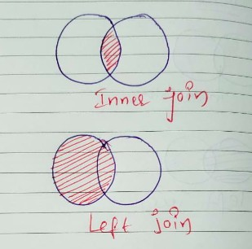
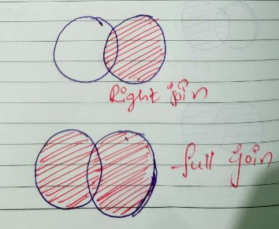
val df1 = spark.read.format("csv").option("header", "true")
.load("file:///home/Practice/data/join1.csv")

val df2 = spark.read.format("csv").option("header", "true")
.load("file:///home/Practice/data/join2.csv")

println("====== Inner Join ============") df1.join(df2, df1("txnno") === df2("tno"), "inner")
.drop("tno")
.show()

println("====== Left Join ============") df1.join(df2, df1("txnno") === df2("tno"), "left")
.drop("tno")

.show()

println("====== Right Join ============") df1.join(df2, df1("txnno") === df2("tno"), "right")
.drop("txnno")
.select("tno", "txndate", "amount", "custno", "spendby")
.show()

println("====== Full Join ============") df1.join(df2, df1("txnno") === df2("tno"), "full")
.withColumn("txnno", expr("case when txnno is null then tno else txnno end"))
.drop("tno")
.show()

println("====== Left-Anti Join ============") df1.join(df2, df1("txnno") === df2("tno"), "left_anti")
.drop("tno")
.show()

Tasks -

=====================================================================
Task #1. Read data.csv file and only print specific columns in dataframe
=====================================================================
/* read file */
val df = spark.read.format("csv").option("header", true)
.load("file:///home/Practice/data/usdata.csv")

/* print only specific columns */
df.select("first_name", "last_name").show()

=====================================================================
Task #2. Select only year from date column value
Using selectExpr,w e can run any sql function over any column
=====================================================================
println("======= use of 'selectExpr' example ========") df.selectExpr("id",
"split(tdate, '-')[2] as year", /* divide date with ‘-’ and select 2nd index */ "amount",
"concat(category, ', done')", "product").show()

=====================================================================
Task #3. Add new column and provide ‘0’ or ‘1’ as per spendBy column values Using selectExpr,we can run any sql function over any column
=====================================================================
println("======= use of 'selectExpr' example ========") df.selectExpr("id",
"split(tdate, '-')[2] as year", /* divide date with ‘-’ and select 2nd index */ "amount",
"concat(category, ', done')", "Product",
"case when spendby = 'case' then 0 else 1 end as STATUS").show()

================================================================
Task #4 - Get Day of the week from Date and Timestamp columns
================================================================
df.withColumn("date", to_date(col("date"), "d/M/yyyy")) /* Converts the column into a `DateType` with a specified format` */
.withColumn("Day", date_format(col("date"), "EE")) /* Converts a date/timestamp/ to a value of string in the format specified by the date format given by the second argument. */
.groupBy("dispatching_base_number", "Day")
.agg(sum("trips").as("Total Trips"))
.orderBy(col("Total Trips"))
.show()

Scala Technical Questions

- Difference between sc.textﬁle() and sc.wholeTextFiles()?
sc.textﬁle() →Each row will be a record
sc.wholeTextFiles() → read the entire content of a ﬁle as a single record
val readDataUsingTextFile = sc.textFile("file:///home/Practice/data/data2.txt")
val readDataUsingWholeTextFiles = sc.wholeTextFiles("file:///home/Practice/data/data2.txt") val result = readDataUsingTextFile.map(x => (x,1))
val result2 = readDataUsingWholeTextFiles.map(x => (x,1))

println("==== result using text file ======")
result.take(2)foreach(println) // ‘1’ is added after every row record println("==== result using whole text file ======")
result2.take(2).foreach(println) // “1” is added after all content of file
—------------------------------------------------------------------------
sc.textFile() result || sc.wholeTextFiles() result

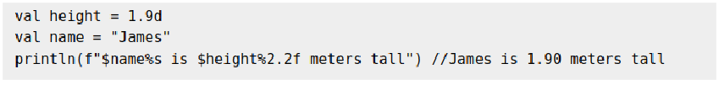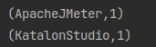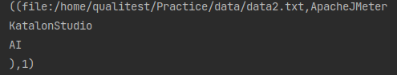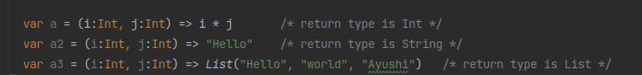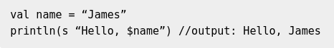

—------------------------------------------------------------------------

- Function return type is Unit, what does it mean?

Unit type is the same as void in JAVA, which means the function doesn’t return anything

- What is closure?

Closure is like a Function whose return type is deﬁned on the expression. Closure can be deﬁned in any scope (class, Object, function)

- What is String Interpolation?
  - The ‘s’ String Interpolator
The literal ‘s’ allows the usage of variable directly in processing a string, when you prepend ‘s’ to it

  - The ‘ f ’ Interpolator
The literal ‘f’ interpolator allows to create a formatted String, similar to printf in C language

  - ‘raw’ Interpolator

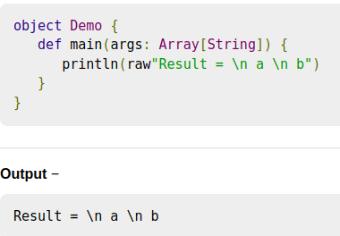
The ‘raw’ interpolator is similar to ‘s’ interpolator except that it performs no escaping of literals within a string.

- What is Pattern Matching?

It is the same as the Switch case in Java.
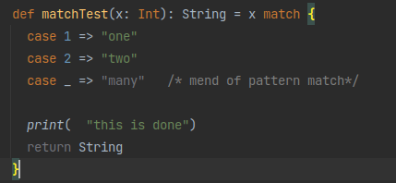

- Exceptional Handling in Scala?

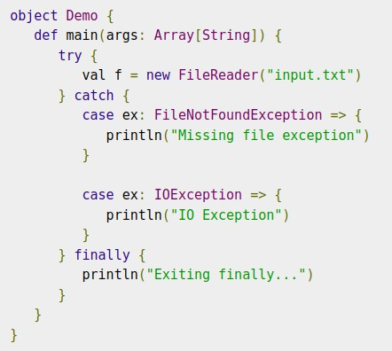

- What is a Match expression?
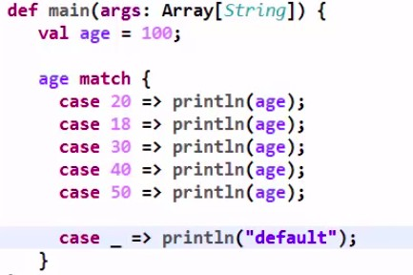
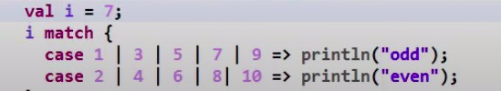

- Basic ways to write functions in Scala?
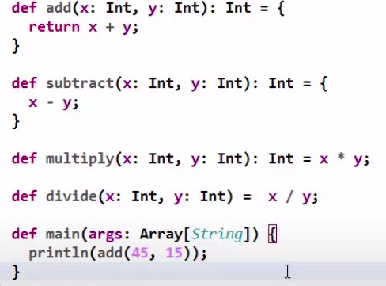

- What are Anonymous functions in Scala?

Without giving any name to a function we can assign it to a Variable, it's called Anonymous function.
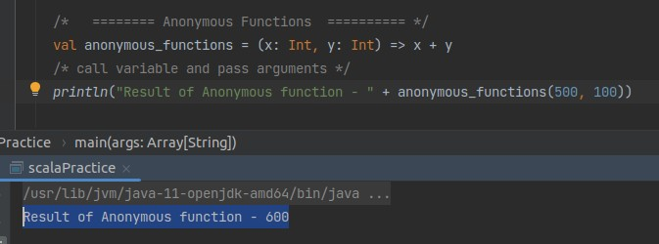

- What are Higher order functions?

Higher order functions are those functions which are able to take functions as arguments and are able to return functions as result.

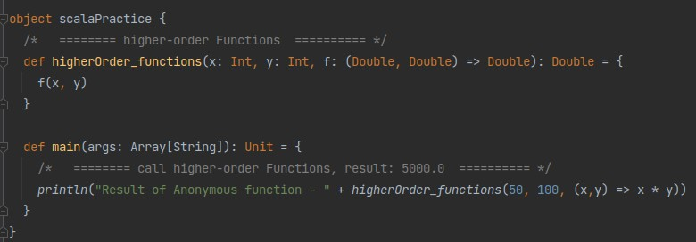

- Deﬁne Array in scala?
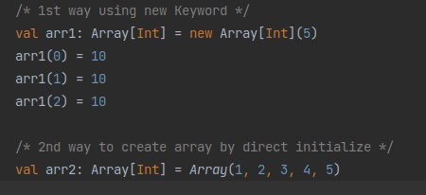

- How to concat two Arrays in Scala?
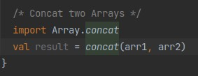

- How to deﬁne For Loop in Scala?

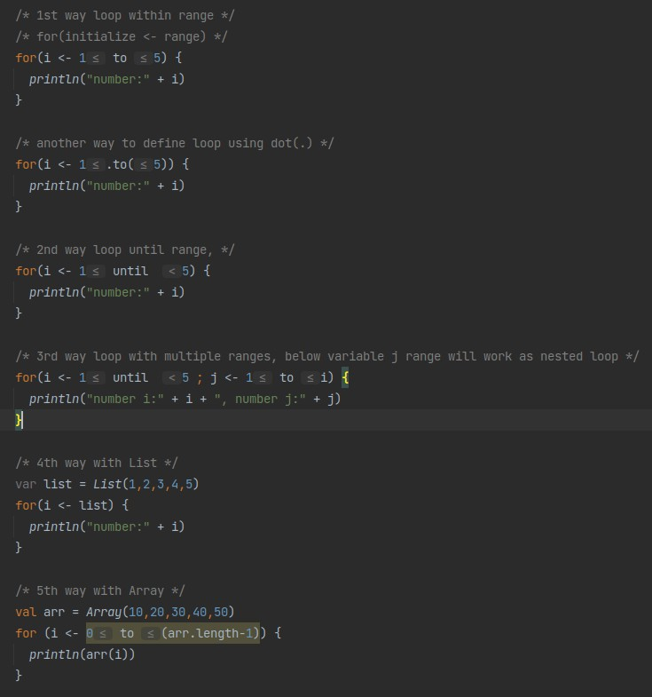

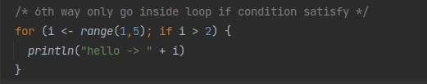

- Deﬁne List in Scala?

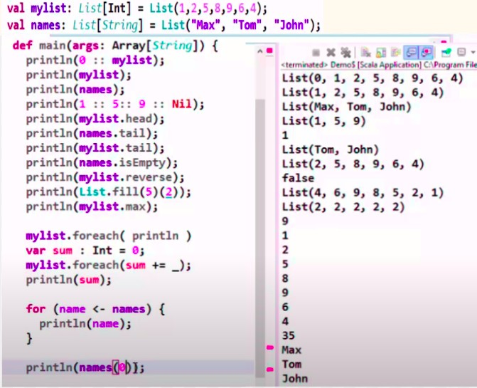

- How to deﬁne sets in Scala?
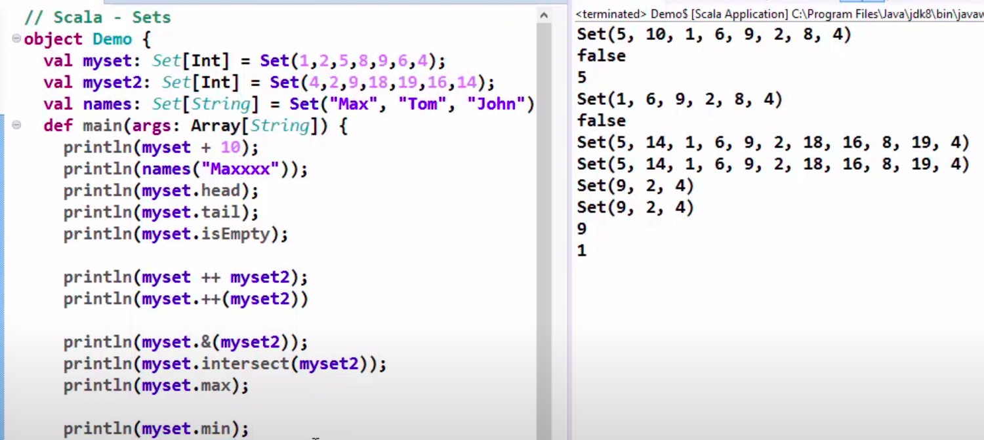

- Map in scala?

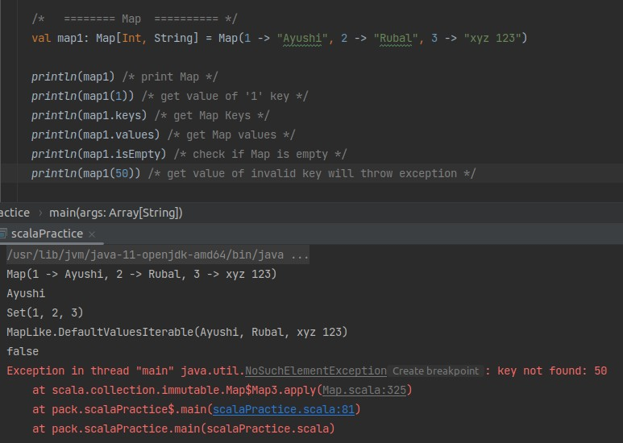

- Tuples in scala?

Tuples can contain elements of different/heterogeneous data-types. Tuples are immutable and they are ﬁxed size.
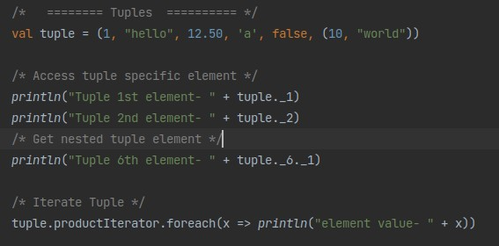

There is another way to deﬁne Tuples using new keyword, depend on size of tuple elements us that Tuple, for example if Tuple have 2 elements use Tuple2 -

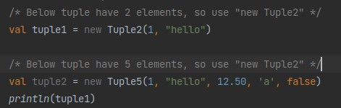

- Reduce, fold and scan methods?
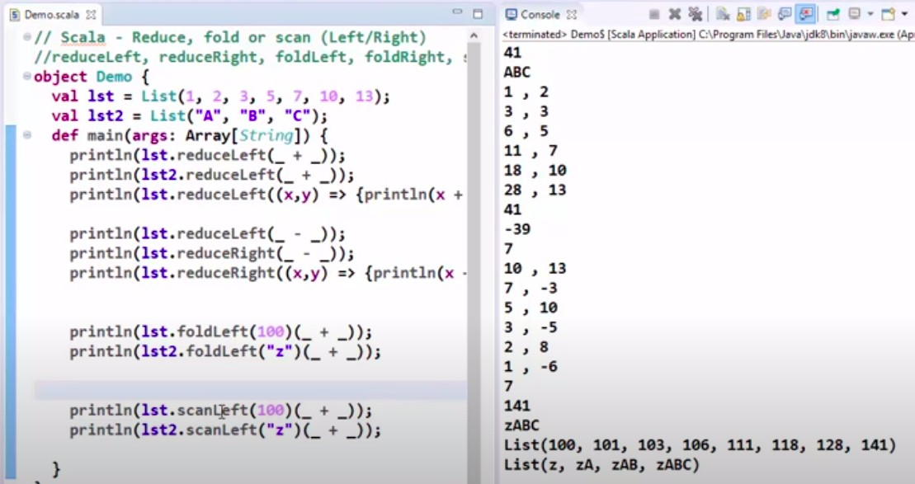

- Scala classes and constructors ?

Singleton class - If deﬁne a class with “object” keyword, it means the class is a singleton and can’t create an instance of this class.
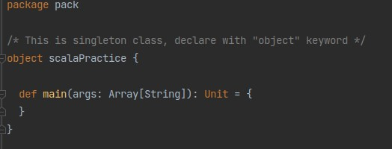

Class -

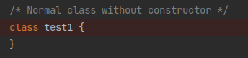

- Primary constructor and Auxiliary Constructors?

Primary constructor —>
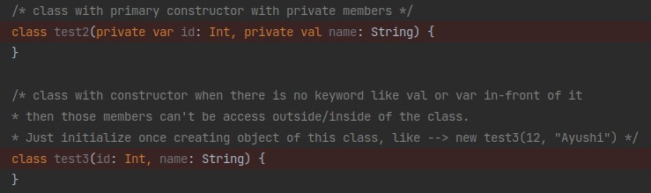

Auxiliary constructor —>

  - Auxiliary constructors are the alternative constructors for a class and are deﬁned as methods in the class with the name "this".
  - The auxiliary constructor in Scala is used for constructor overloading.
  - A class can have many auxiliary constructors but they should have different signatures and must call any previously deﬁned constructors.

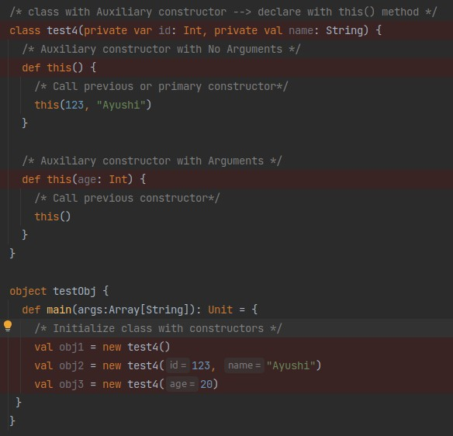

- Inheritance in Scala?

Scala doesn’t support multiple inheritances just like java
Super class

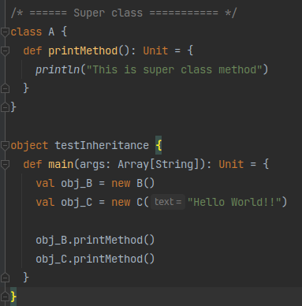

Subclass - Use “override” keyword to override the parent method.
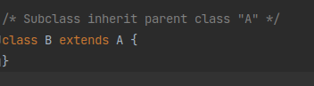
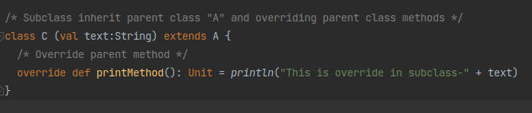

- Abstract class in Scala?

An abstract can be initialized. Abstract methods should be implemented in the subclass.
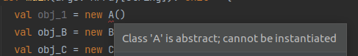
Super class

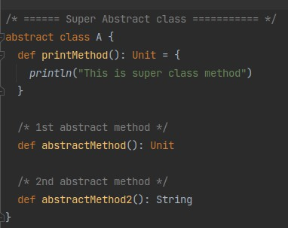

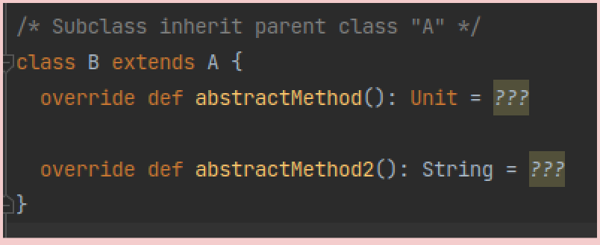
Subclass -
- Scala lazy Evolution?

Scala supports strict evolution and lazy evolution

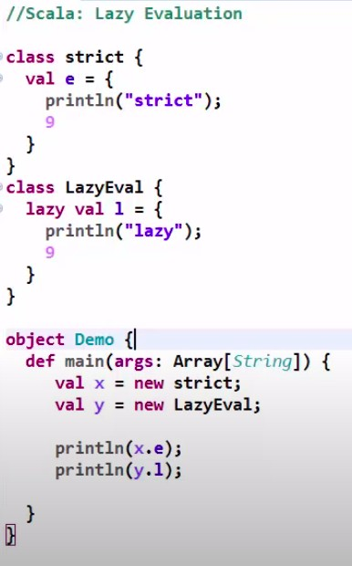

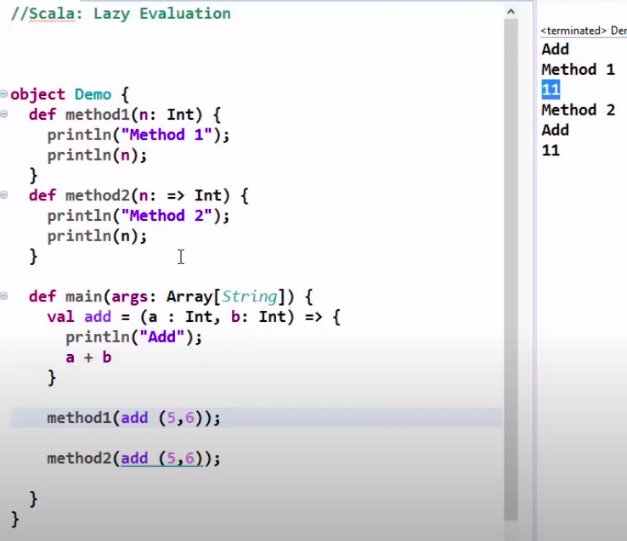

- Scala Trait?

Traits are like interfaces, they are partially implemented interfaces. We can inherit Trait using the “with” keyword just like “implements” keyword in java.
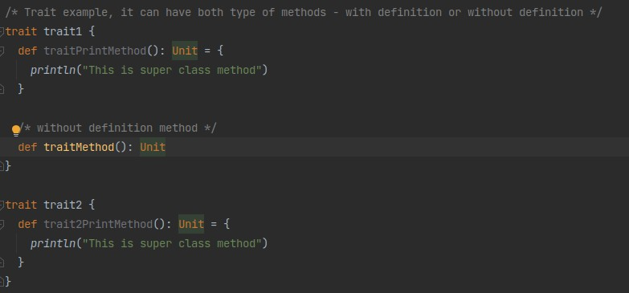

Just add “with” to inherit as many Traits you want, just like below we have added “with” two times to inheriting each Trait.
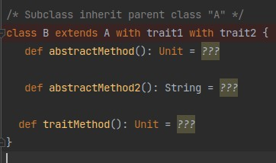

INTERVIEW QUESTIONS -
- What is Hadoop?
Ans - Hadoop
Hadoop is a framework that uses distributed storage and parallel processing to store and manage big data. It is the software most used by data analysts to handle big data, and its market size continues to grow.
- What is the mechanism for distributed Storage and distributed processing?

Ans -distributed Storage → DFS and distributed processing →MapReduce

- What is the block size in 1.0 and 2.0?
Ans → Block size in Hadoop 1.0 ➺ 64 MB

Block size in Hadoop 2.0 ➺ 120 MB
- What are name nodes, edge Node, secondary name, and data node?
Ans →name node ➺ Master Node edge Node ➺ Client Node
secondary name ➺ Where we do checkpointing data node ➺ Where store our data
- What is the heartbeat interval? Ans - 30 sec
- What is stale/grace time? Ans - 10 min
- What is under replication and over replication?

Ans - When data nodes have more than 3 replicas of the same data it is called Over replication and when data nodes have less than 3 replicas of the same data it is called under replica.
- Do name nodes do checking points? Ans - No, but once it goes to safemode and becomes a secondary node it will do checkpointing.
- What is safe mode? Ans - Read Hadoop 2.0 Architecture
- Difference between edit log and FS Image?
Ans - Edit log have metadata of current Transaction while FS Image has metadata of all Transaction.
- Drawbacks of Hadoop 1.0? Ans - Defects of Hadoop 1.0
- Who monitors nodes in 2.0? Ans - ZooKeeper
- What are journal nodes? Ans - We write EL in journal node
- What is the split-brain scenario? Ans - Read Hadoop 2.0 Architecture
- What is the in_use.lock ﬁle? Ans - Read Hadoop 2.0 Architecture
- What is fencing? Ans - Read Hadoop 2.0 Architecture
- Insert 10 records in the RDBMS table and then Sqoop imports only Chennai records with columns only ﬁrstname, lastname?
- st Way using Where

sqoop import --connect jdbc:mysql://localhost/sqldb --username root --password cloudera --table customer --m 1
--where "city='chennai'" --columns ﬁrstname, lastname --delete-target-dir --target-dir /user/cloudera/revdir

- 2nd Way using Query
sqoop import --connect jdbc:mysql://localhost/sqldb --username root --password cloudera

--query "SELECT ﬁrstname, lastname from customer where city='chennai' and \$CONDITIONS" --m 1 --target-dir /user/cloudera/revdir

- Some questions in Tasks/Interview questions
- What do you mean by the term or concept of Big Data?
Ans - What is Big Data?
- What are the characteristics of Big Data?
Ans - 5 V’s - (now its 6 V’s)
- Deploying a Big Data solution includes the following steps?
  - Data Ingestion: As a ﬁrst step, the data is drawn out or extracted from various sources so as to feed it to the system.
  - Data Storage: Once data ingestion is completed, the data is stored in either HDFS or NoSQL database.
  - Data Processing: In the ﬁnal step, the data is processed through frameworks and tools such as Spark, MapReduce, Pig, etc.
- What is the reason behind using Hadoop in Big Data analytics?
Ans - Businesses generate a lot of data in a single day and the data generated is unstructured in nature. Data analysis with unstructured data is difﬁcult as it renders traditional big data solutions ineffective. Hadoop comes into the picture when the data is complex, large, and especially unstructured. Hadoop is important in Big Data analytics because of its characteristics:
  - Data storage
  - Data processing
  - Collection plus the extraction of data
- What do you understand by fsck in Hadoop?
fsck stands for ﬁle system check in Hadoop, and is a command that is used in HDFS. fsck checks any and all data inconsistencies. If the command detects any inconsistency, HDFS is notiﬁed regarding the same.
- Can you explain some of the important features of Hadoop? Some of the important features of Hadoop are:
  - Fault Tolerance: Hadoop has a high-level of fault tolerance. To tackle faults,
Hadoop, by default, creates three replicas for each block at different nodes. This number can be modiﬁed as per the requirements. This helps to recover the data from another node if one node has failed. Hadoop also facilitates the automatic recovery of data and node detection.
  - Open Source

  - Distributed Processing: Hadoop stores the data in a distributed manner in HDFS. Distributed processing implies fast data processing. Hadoop also uses MapReduce for the parallel processing of the data.
  - Reliability: One of the beneﬁts of Hadoop is that the data stored in Hadoop is not affected by any kind of machine failure, which makes Hadoop a reliable tool.
  - Scalability: Scalability is another important feature of Hadoop. Hadoop’s compatibility with other hardware makes it a preferred tool. You can also easily add new hardware to the nodes in Hadoop.
  - High Availability: Easy access to the data stored in Hadoop makes it a highly preferred Big Data management solution. Not only this, the data stored in Hadoop can be accessed even if there is a hardware failure as it can be accessed from a different path.
- What is Hadoop and what are its components?
Apache Hadoop is the solution for dealing with Big Data. Hadoop is an open-source framework that offers several tools and services to store, manage, process, and analyze Big Data. This allows organizations to make signiﬁcant business decisions in an effective and efﬁcient manner, which was not possible with traditional methods and systems.
Components of Hadoop
- Explain Hadoop Architecture. Hadoop 2.0 Architecture
- In what all modes can Hadoop be run?
ANS - Hadoop can be run in three modes:
  - Standalone Mode: The default mode of Hadoop, standalone mode uses a local ﬁle system for input and output operations. This mode is mainly used for debugging purposes, and it does not support the use of HDFS. Further, in this mode, there is no custom conﬁguration required for mapred-site.xml,
core-site.xml, and hdfs-site.xml ﬁles. This mode works much faster when compared to other modes.
  - Pseudo-distributed Mode (Single-node Cluster): In the case of
pseudo-distributed mode, you need the conﬁguration for all the three ﬁles mentioned above. All daemons are running on one node; thus, both master and slave nodes are the same.
  - Fully distributed mode (Multi-node Cluster): This is the production phase of Hadoop, what it is known for, where data is used and distributed across several nodes on a Hadoop cluster. Separate nodes are allotted as master and slave nodes.
- What is Hadoop federation?
- What is the hive ﬁle format? Explain the Use case. ( for example And why are you using Parquet, why not ORC?)
Ans - Serialization File Types in SQOOP

Hive File Formats
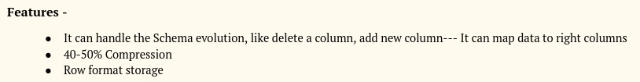
- Difference between Parquet and AVRO ﬁle format? Avro Data ﬁle -
PARQUET -
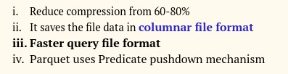

- how to put data from hive to Hadoop?

Ans - Data in Hive tables reside on HDFS, Hive is only a metadata layer that helps you access the HDFS data in form of tables and rows.
So you don’t transfer data from Hive to HDFS, as the data is already on HDFS.

- Partition vs Bucketing? Ans - Partition Vs Bucketing
- Default Partition Algorithm used in MapReduce and Spark? Or
Hive Bucket Internal formula?
Ans - How Bucket decides which part ﬁle records will go

- How can I execute external ﬁles inside the hive?

- Window function in Hive.

- How can you transfer data from Hive to HDFS?

- How does MapReduce work?

- What is the difference between Tez and map-reduce?
- What are the various steps involved in deploying a Big Data solution?

- Spark Structure (How the job is executed behind the scene.

- Explain Spark Architecture?

- Repartition and Coalesce in SPARK in respective to Performance?

- Transformation in Spark. data like -

  - 1, Ram, 20000, "Ayodhya, Srilanka, India, Varanasi", Yes

  - 2, Shyan 30000, "Bangalore, China, Canada, Hyderabad", No ﬁle name test.csv
Write into hive table as parquet ﬁle

- Broadcast variable

- Lazy evaluation and shufﬂing

- Write Scala code for the following scenario.

- JSON ﬁle HDFS location - /user/warehouse/input/employee.json

- Columns in Json ﬁle -id, name, salary, deptname

- Dataframe API to get the second highest salary.

- Save output dataframe in Parquet format in HDFS - /user/warehouse/output

- Difference between Rank & Dense_rank?

- What is scala ﬁle format?

JSON/TEXT/CSV/XML/Avro/parquet

Scala by default support JSON/text/parquet/CSV but for XML/Avro need to add jars or dependency for support these ﬁles
- Write a word count program in spark.

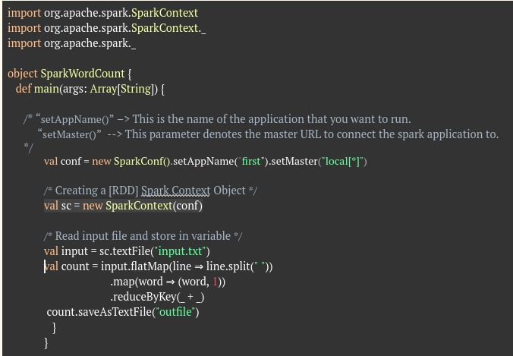

- Which technique did you use to display your code?

- Write a Query to bind duplicate numbers?

- What are nil and null?

- What is transformation, action?

- What is the access modiﬁer in scala?

There is no public modiﬁer, if no modiﬁer is deﬁned it is public by default. Protected can we access either in subclass or sub-package.

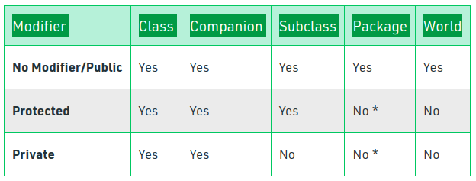

- how to debug in Hadoop?

- scala version? spark version?
  - Scala - 2.1112
  - Spark - 2.4.7

- What package is used in scala?
  - Org.apache.spark.Sparkcontext
  - org.apache.spark.SparkSession
  - org.apache.spark.sql

- Once the ﬁle is loaded from HDFS to Hive, Why is the ﬁle moved completely to the Hive location(/user/hive/warehouse/)?
Ans -Although there is no documentation of why it happens. But I think HDFS shouldn’t keep copies of the same data in two places(HDFS and HIVE)
- What will happen if we don’t set “var conf = new SparkConf().setAppName(“”).setMaster(“”)” to “var sc = SparkContext()”?

- Difference Between var and val in Scala?
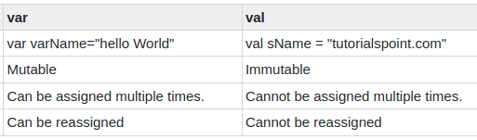

- In which Spark version was SparkSession introduced?

Ans - SparkSession was introduced in version Spark 2.0

- What is Batch processing and stream processing?

Batch Processing - Your input data is stored in a ﬁle or database on which you are doing some processing and getting output. Using Hadoop, we can do batch processing
Stream Processing - Data coming live means not stored anywhere in the system and you are processing live data and getting the output, which is called Stream Processing. Using Spark, we can do Stream processing
- How to migrate or take data from one place to another place in Spark?
